
Prairie Cordgrass
Spartina pectinata

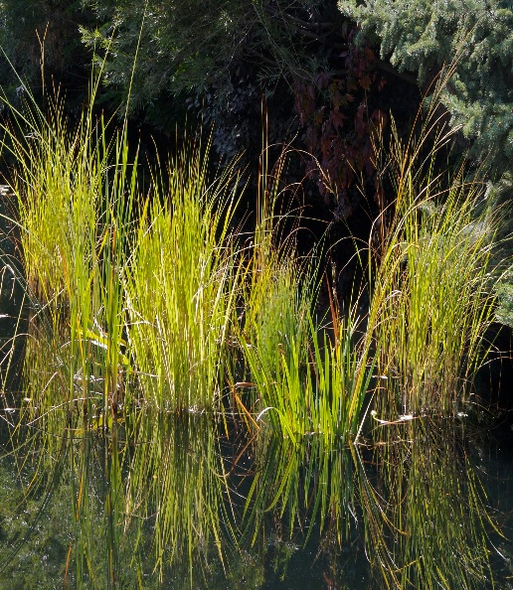
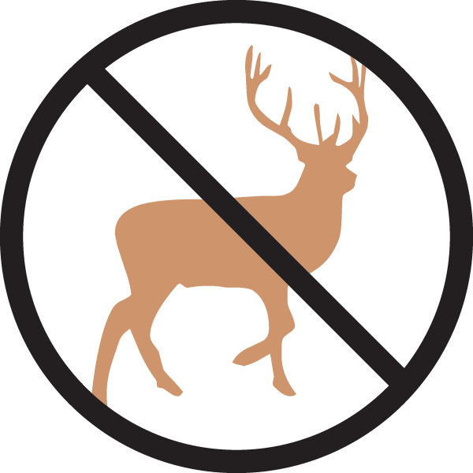
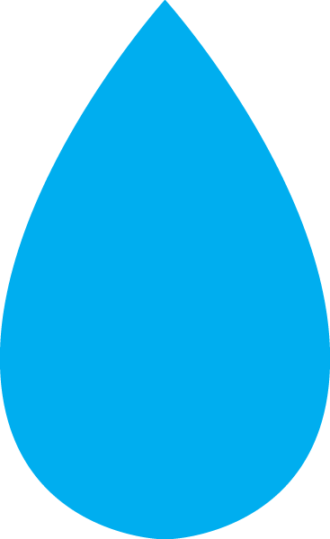
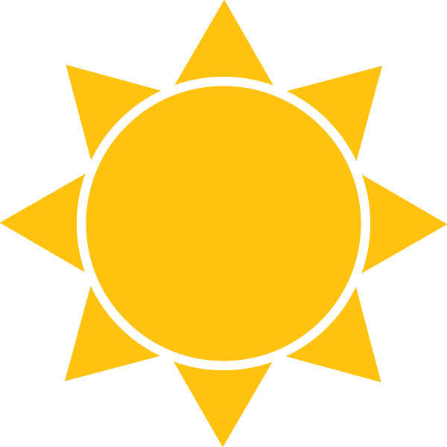

Height: 20-30 in. Width: 20-30 in.
This dramatic native grass of wetlands makes a superlative container plant for a pond garden. Graceful, weeping form takes on rich golden tints in autumn, glowing in sunset light. Keep in container to control spreading.
Culture: Clay or loam soil
Hardiness: USDA zones 4-8



WIND. HAIL. SNOW. SUN
BRING IT ON

www.plantselect.org



