

**Prairie Cordgrass**

*Spartina pectinata*

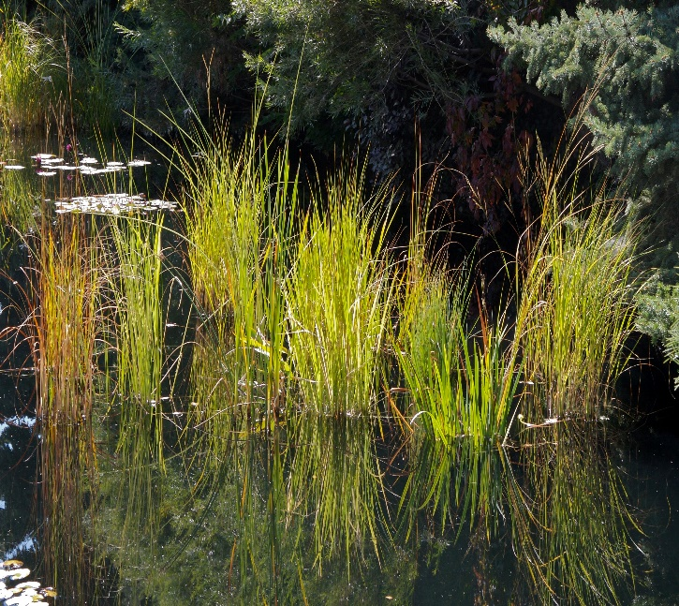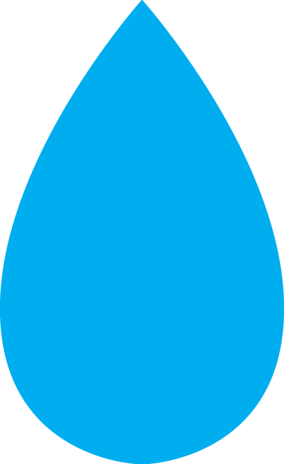

**Height: 20-30 in. Width: 20-30 in.**

This dramatic native grass of wetlands makes a superlative container plant for a pond garden. Graceful, weeping form takes on rich golden tints in autumn, glowing in sunset light. Keep in container to control spreading.

**Culture:** Heavy clay loam

**Hardiness:** USDA zones 4-8



WIND. HAIL. SNOW. SUN

**BRING IT ON**

www.plantselect.org

