
Thin Man Indian Grass
Sorghastrum nutans ‘Thin Man’ PPAF

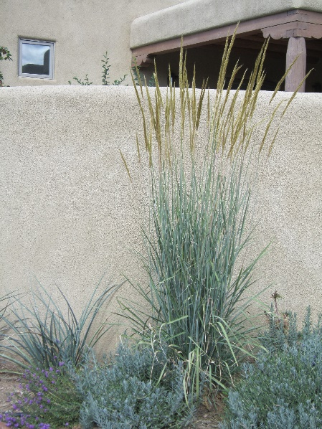



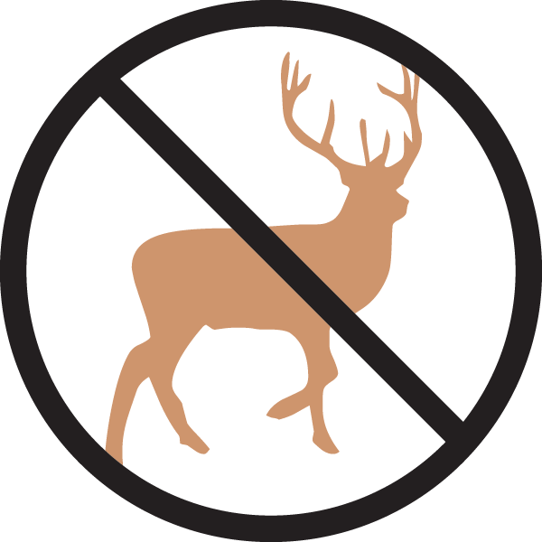


Height: 72 in. Width: 24-30 in.
Thin Man has stunning blue foliage and a narrow, very upright growing habit to the leaves and flower spikes. Blooming in late summer, the golden-bronze-colored flowers are very showy and provide big seeds that feed songbirds and other animals.
Culture: Clay, loam or sandy soil
Hardiness: USDA zones 4-9



WIND. HAIL. SNOW. SUN
BRING IT ON

www.plantselect.org



