

**Thin Man Indian Grass**

*Sorghastrum nutans ‘Thin Man’* PPAF

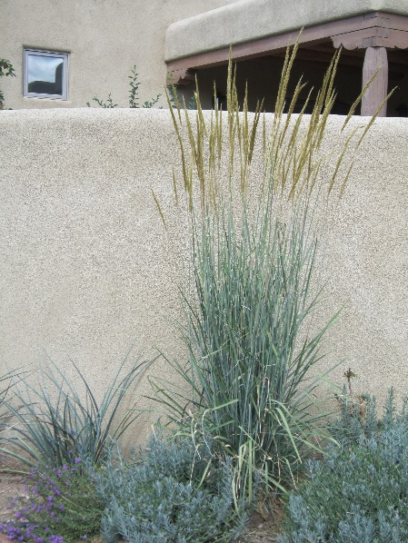

**Height: 72 in. Width: 24-30 in.**

Thin Man has stunning blue foliage and a narrow, very upright growing habit to the leaves and flower spikes. Blooming in late summer, the golden-bronze-colored flowers are very showy and provide big seeds that feed songbirds and other animals.

**Culture:** Clay, loam or sandy soil

**Hardiness:** USDA zones 4-9



WIND. HAIL. SNOW. SUN

**BRING IT ON**

www.plantselect.org

