

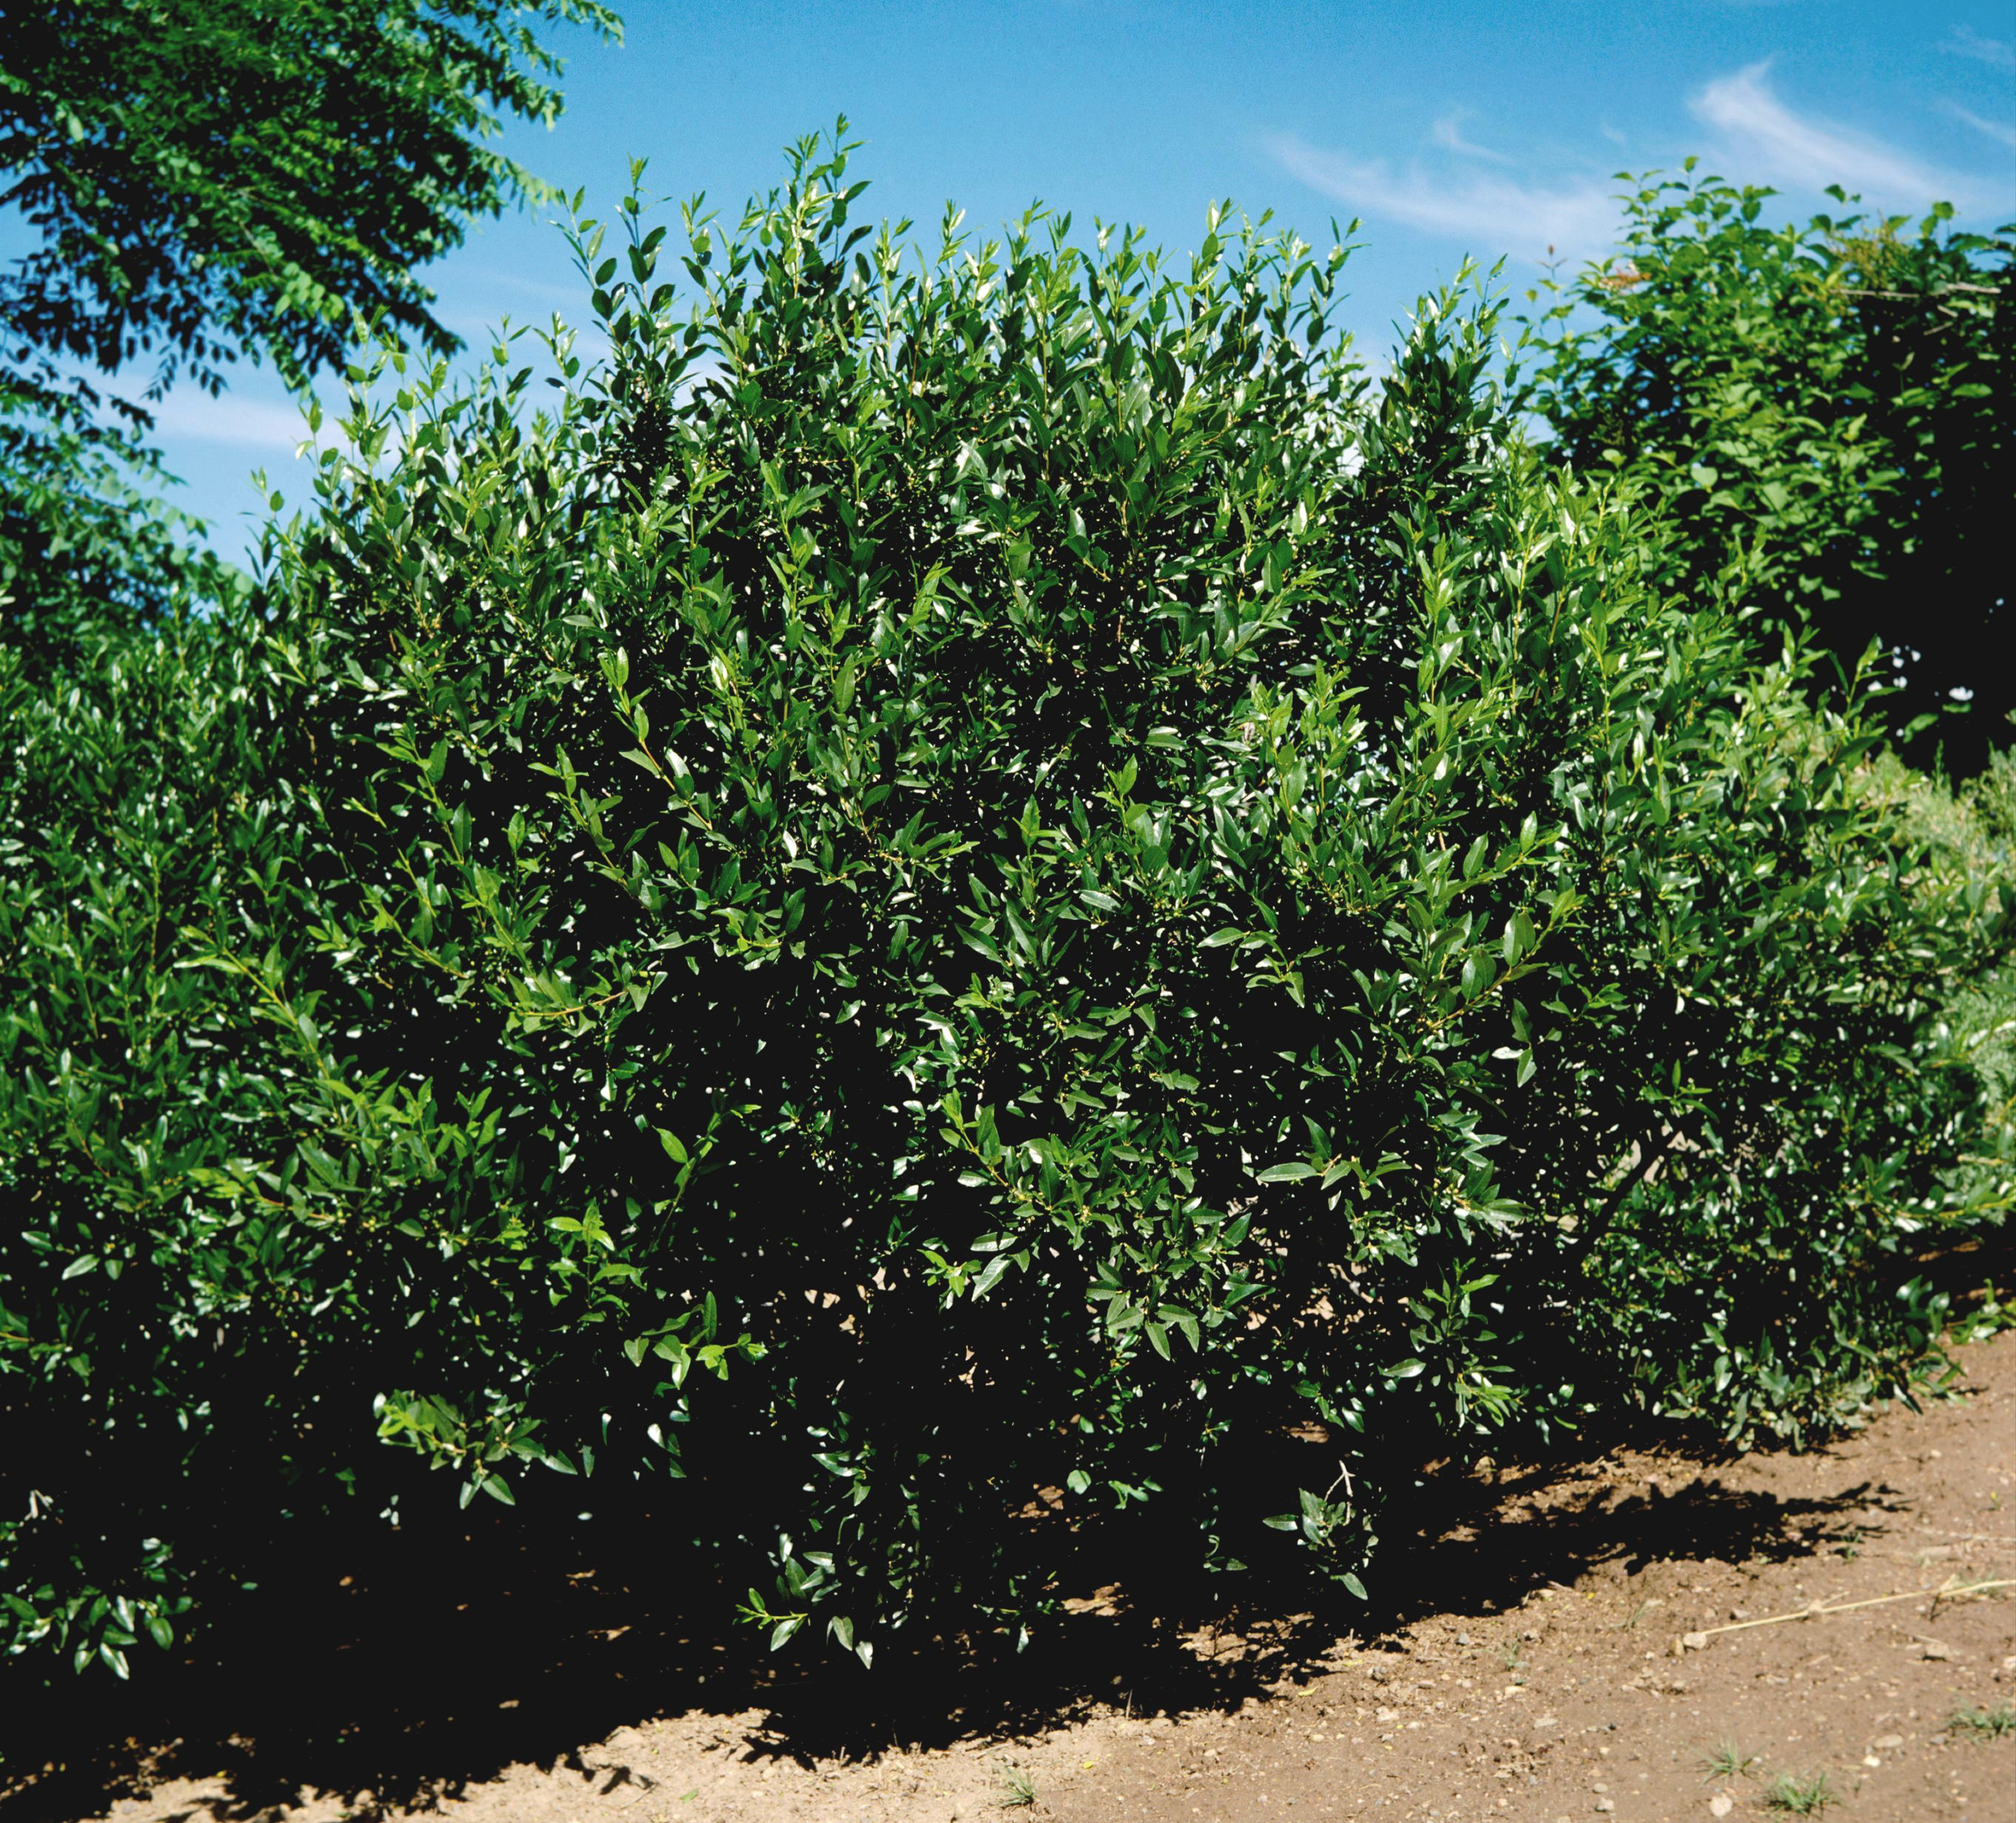
Height: 4-5’
Width: 6-8’
Blooms: White flowers in June
Sun: Full sun to partial shade
Water: Moderate to dry
Hardiness: USDA zones 4-8
Culture: Sandy soil or clay loam
Introduced: 2002
Shrub
A dramatic landscape plant form Siberia. This shrub has attractive, gray-green foliage and showy panicles of white flowers in summer. It is a selection at the Hildreth-Howard Arboretum at Cheyenne, Wyoming, formerly known as the USDA Field Station, where the parent plant has thrived over many decades with minimal care and irrigation.

Siberian Spiraea
Sibiraea laevigata
www.plantselect.org

