
Siberian Spiraea
Sibiraea laevigata


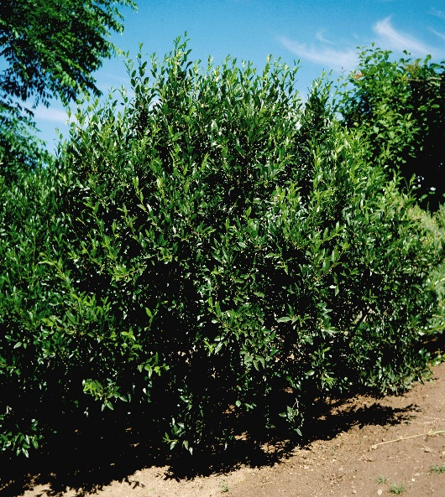





Height: 4-5 ft. Width: 6-8 ft.
A dramatic landscape plant form Siberia. This shrub has attractive, gray-green foliage and showy panicles of white flowers in summer. It is a selection at the Hildreth-Howard Arboretum at Cheyenne, Wyoming, where the parent plant has thrived over many decades with minimal care and irrigation.
Culture: Clay, loam or sandy soil
Hardiness: USDA zones 4-8



WIND. HAIL. SNOW. SUN
BRING IT ON

www.plantselect.org



