

**Siberian Spiraea**

*Sibiraea laevigata*

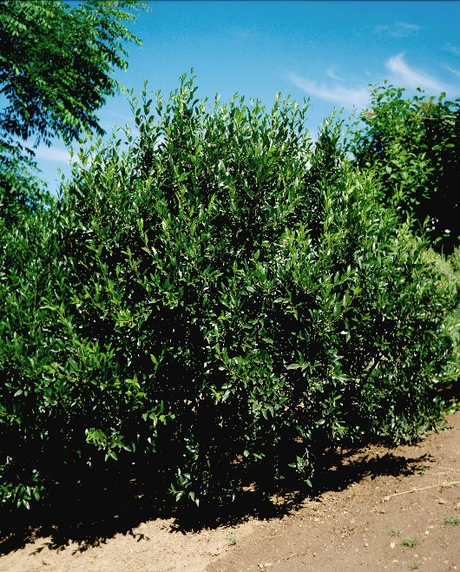

**Height: 4-5 ft. Width: 6-8 ft.**

A dramatic landscape plant form Siberia. This shrub has attractive, gray-green foliage and showy panicles of white flowers in summer. It is a selection at the Hildreth-Howard Arboretum at Cheyenne, Wyoming, where the parent plant has thrived over many decades with minimal care and irrigation.

**Culture:** Clay, loam or sandy soil

**Hardiness:** USDA zones 4-8



WIND. HAIL. SNOW. SUN

**BRING IT ON**

www.plantselect.org

