

**Shimmer evening primrose**

*Oenothera fremontii* ‘Shimmer’’PP19*,663*

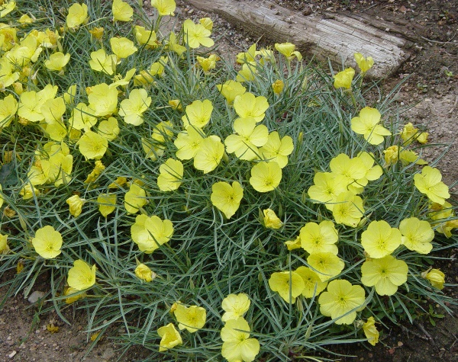

**Height: 8-10 in. Width: 16-18 in.**

Shimmer has cheerful, large lemon-yellow flowers that bloom profusely in late spring and re-bloom in the summer and fall, scenting the evening air with fragrance. Shimmer is a great pollinator plant and native to Kansas and Nebraska. It was selected by horticulturists Lauren Springer & Scott Ogden.

**Culture:** Clay, loam, well-drained soil

**Hardiness:** USDA zones 5a-8b



WIND. HAIL. SNOW. SUN

**BRING IT ON**

www.plantselect.org

