



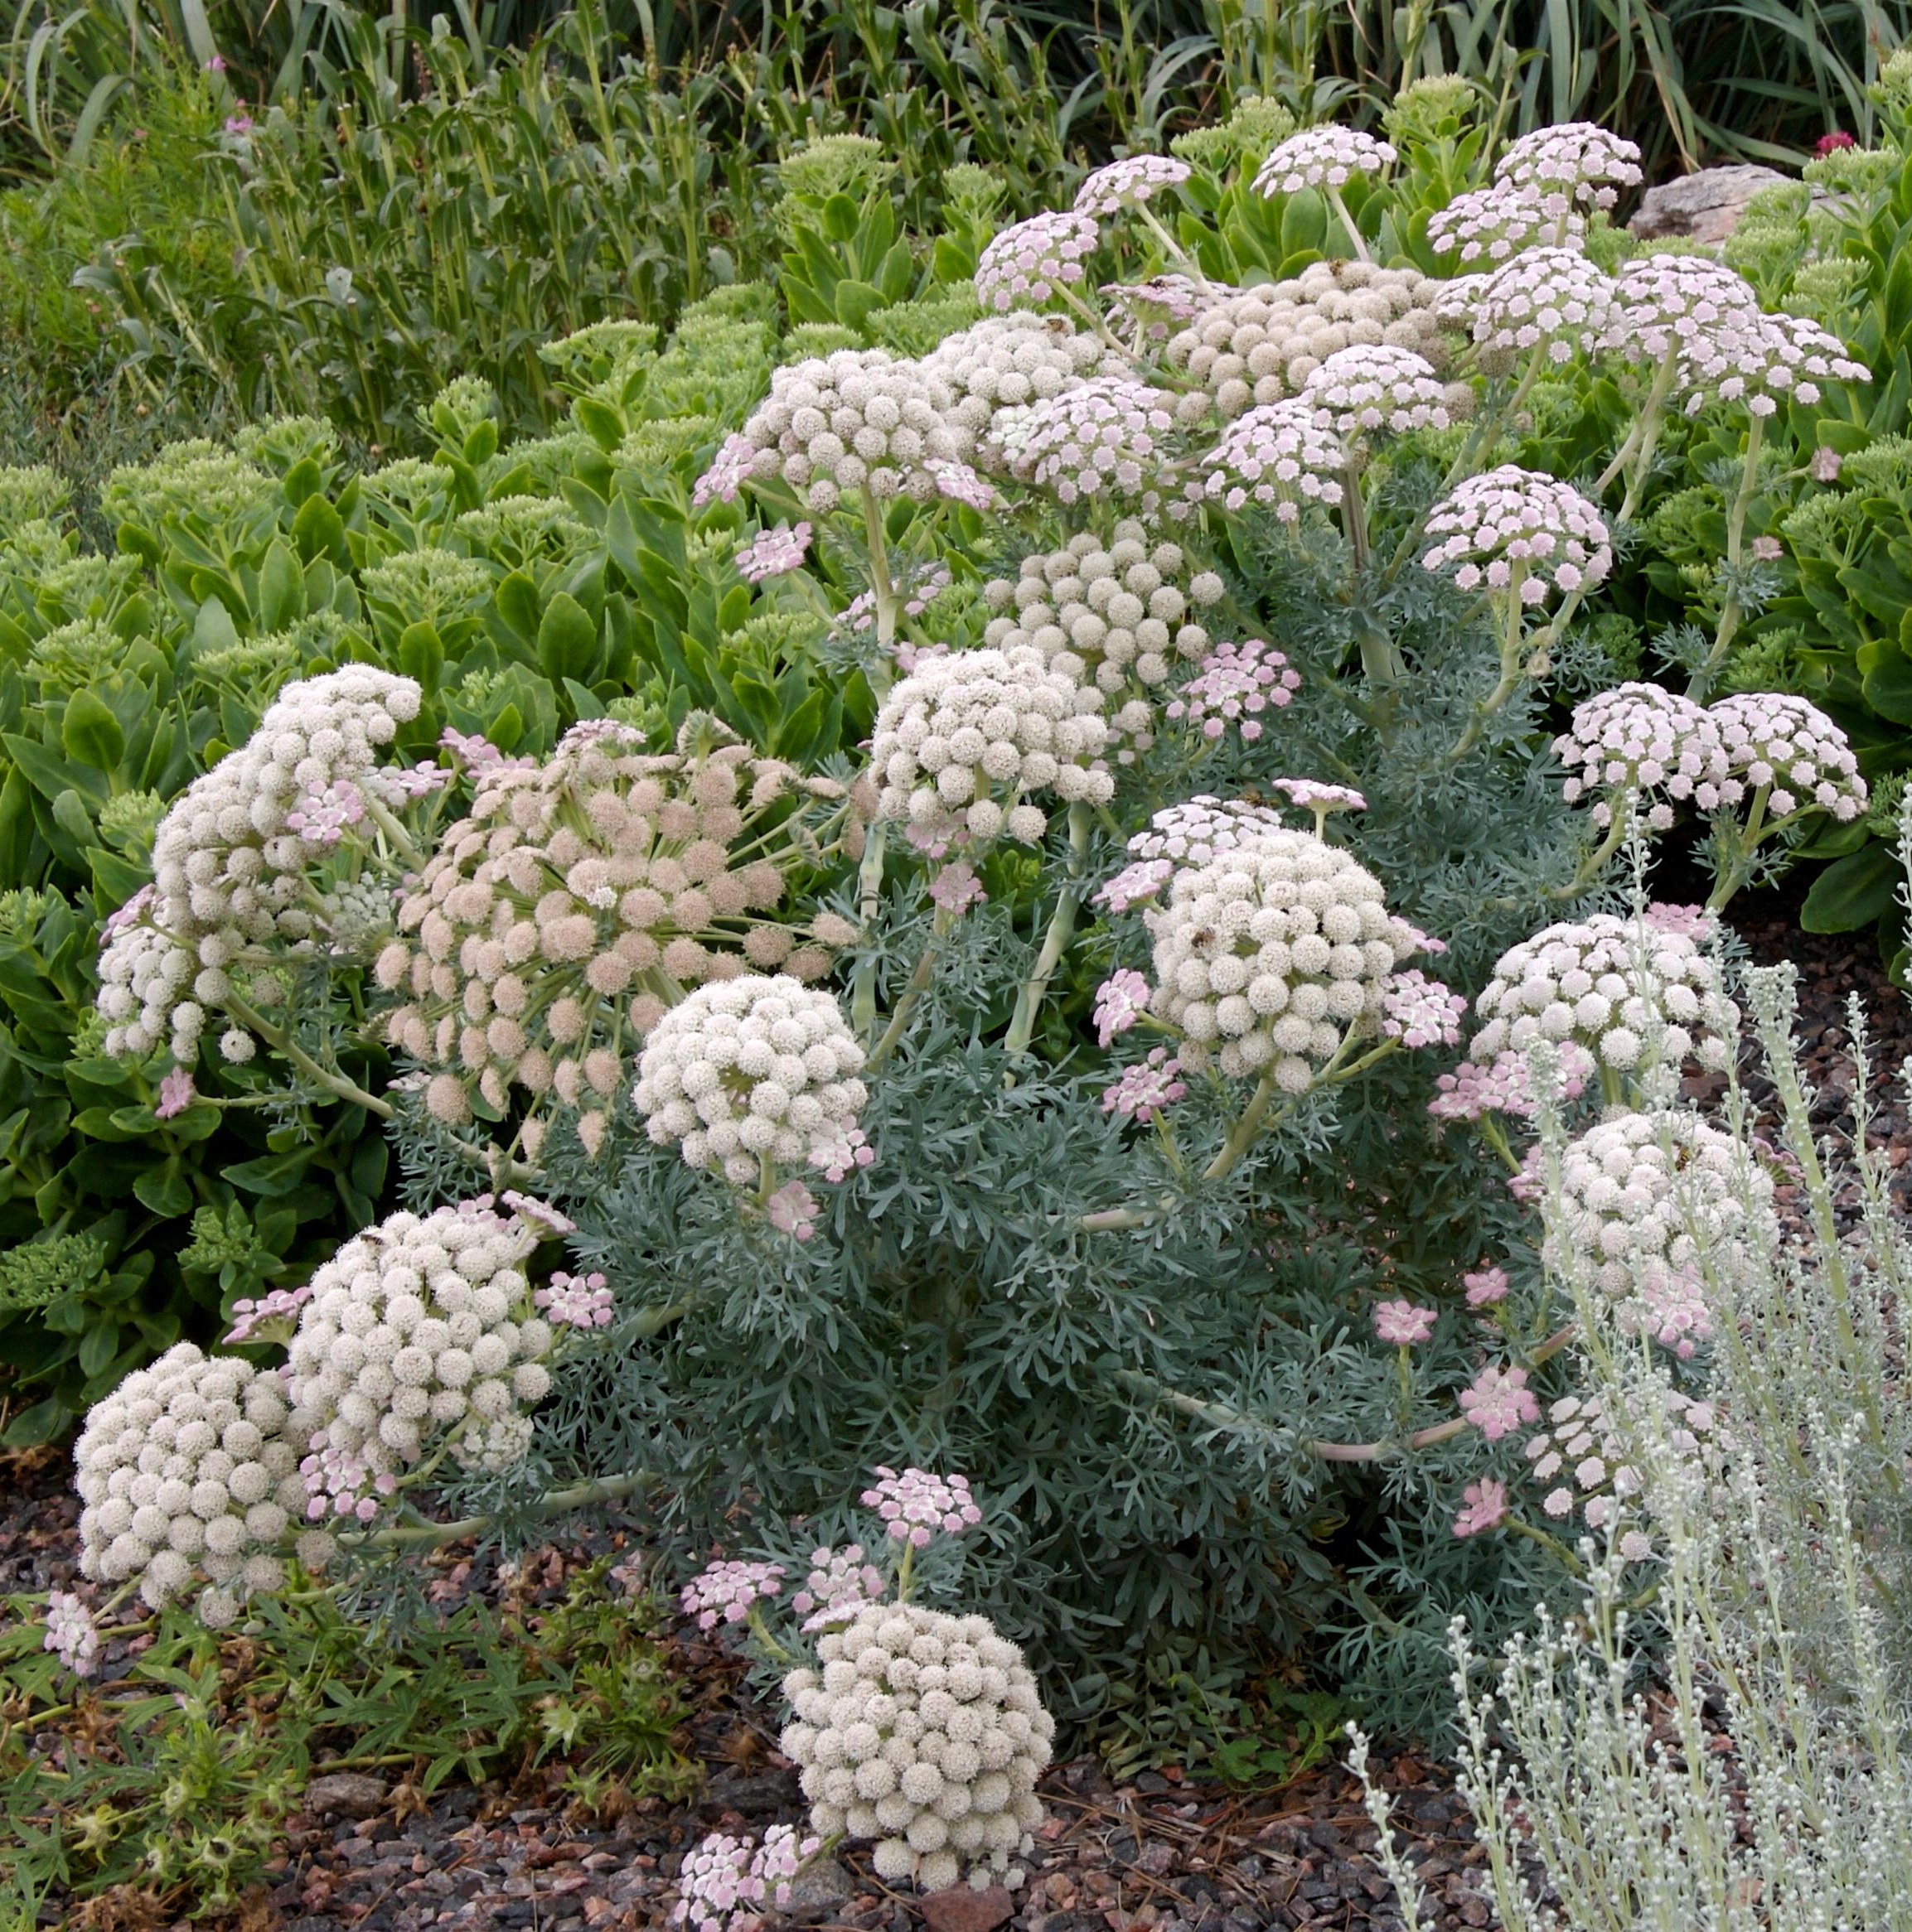
Height: 24-36”
Width: 10-15”
Blooms: Midsummer to fall
Sun: Full sun to partial shade
Water: Moderate to dry
Hardiness: USDA zones 5-9
Culture: Average, clay, or sandy soil
Introduced: 2005
Biennial or short-lived perennial
The basal rosette of succulent, silver-blue lacy, foliage is substantial. The second year it produces a succession of five inch umbel pale pink flowers that fade to white. It is useful as a focal point in the garden.

Moon Carrot
Seseli gummiferum
www.plantselect.org

