
Moon Carrot
Seseli gummiferum

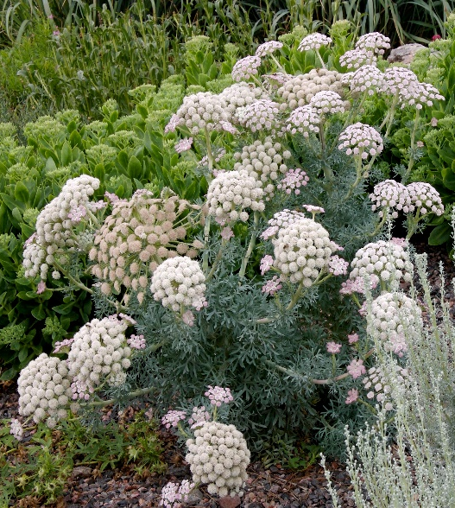








Height: 28-32 in. Width: 10-14 in.
The basal rosette of succulent, silver-blue lacy, foliage is substantial. The second year it produces a succession of five inch umbel pale pink flowers that fade to white. It is useful as a focal point in the garden. Blooms midsummer to fall.
Culture: Clay, loam or sandy soil
Hardiness: USDA zones 5-9



WIND. HAIL. SNOW. SUN
BRING IT ON

www.plantselect.org



