

**Moon Carrot**

*Seseli gummiferum*

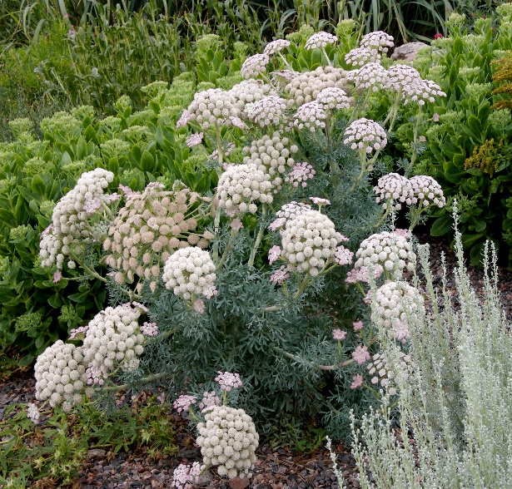

**Height: 28-32 in. Width: 10-14 in.**

The basal rosette of succulent, silver-blue lacy, foliage is substantial. The second year it produces a succession of five inch umbel pale pink flowers that fade to white. It is useful as a focal point in the garden. Blooms midsummer to fall.

**Culture:** Clay, loam or sandy soil

**Hardiness:** USDA zones 5-9



WIND. HAIL. SNOW. SUN

**BRING IT ON**

www.plantselect.org

