
Moon Carrot
Seseli gummiferum




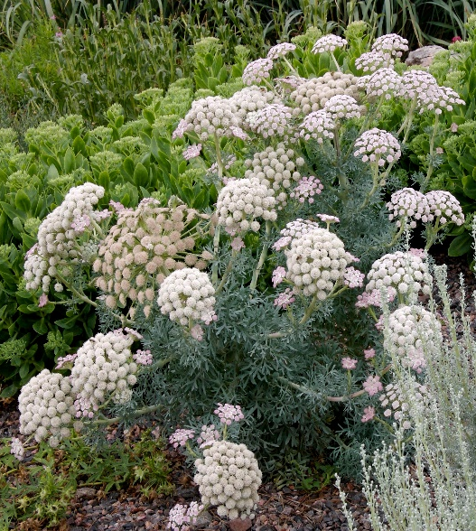





Height: 24-36 in. Width: 10-15 in.
The basal rosette of succulent, silver-blue lacy, foliage is substantial. The second year it produces a succession of five inch umbel pale pink flowers that fade to white. It is useful as a focal point in the garden.
Culture: Clay, loam or sandy soil
Hardiness: USDA zones 5-9



WIND. HAIL. SNOW. SUN
BRING IT ON

www.plantselect.org



