



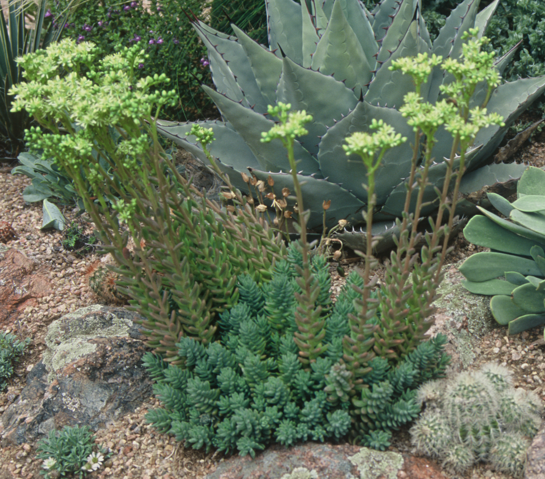
Height: 4-6”
Width: 8-12”
Blooms: June to July
Sun: Full sun
Water: Dry to xeric
Hardiness: USDA zones 5a-10
Culture: Sandy, clay, or loam soil
Introduced: 2013
Succulent Groundcover
Creamy-yellow flowers rise above succulent blue mounds in mid-summer, creating sculptural accent for xeric gardens. Attracts bees, is virtually deer-resistant, suitable for green roofs, and evergreen, too!

Turquoise Tails Blue Sedum
Sedum sediforme
www.plantselect.org

