
Turquoise Tails Blue Sedum
Sedum sediforme



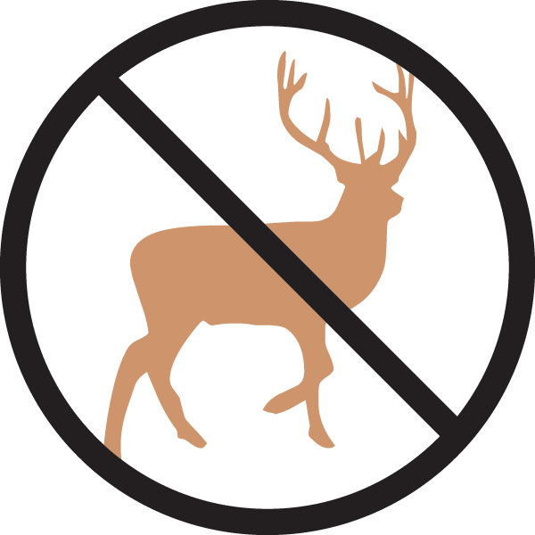



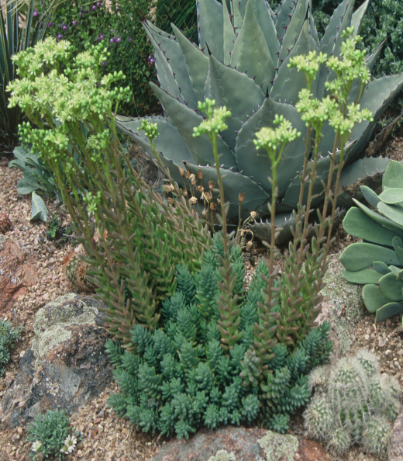

Height: 4-6 in. Width: 8-12 in.
Creamy-yellow flowers rise above succulent blue mounds in mid-summer, creating sculptural accent for xeric gardens. Attracts bees, is virtually deer-resistant, suitable for green roofs, and evergreen, too!
Culture: Clay, loam or sandy soil
Hardiness: USDA zones 5a-10



WIND. HAIL. SNOW. SUN
BRING IT ON

www.plantselect.org



