
Cherry Skullcap
Scutellaria suffrutescens


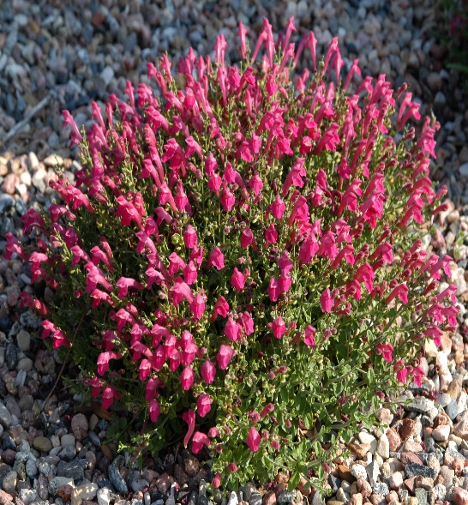





Height: 3-8 in. Width: 10-15 in.
Low mounding subshrub with continuous display of hot, cherry-red flowers. Grows best in sunny, well-drained sites. Good in raised beds, rock gardens, or in front of the border.
Culture: Clay, loam or sandy soil
Hardiness: USDA zones 6-9



WIND. HAIL. SNOW. SUN
BRING IT ON

www.plantselect.org



