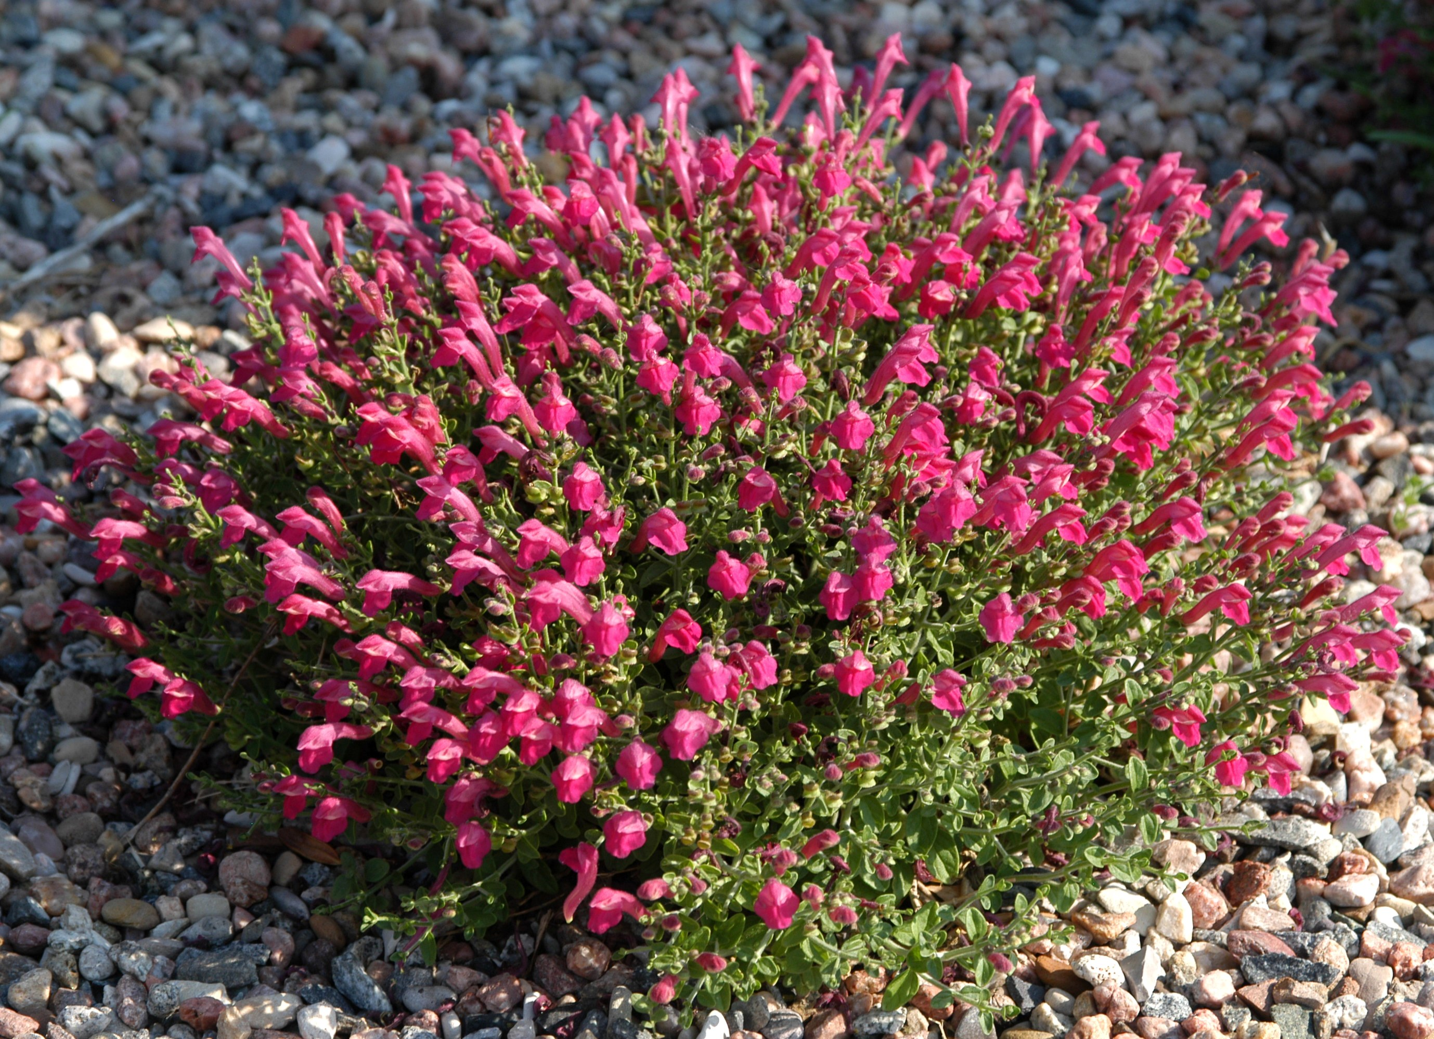



Height: 3-8”
Width: 10-15”
Blooms: Summer to fall
Sun: Full sun to partial shade
Water: Moderate to dry
Hardiness: USDA zones 6-9
Culture: Average, clay, or sandy soil
Introduced: 2004
Tender perennial
Low mounding subshrub with continuous display of hot, cherry-red flowers. Grows best in sunny, well-drained sites. Good in raised beds, rock gardens, or in front of the border.

Cherry Skullcap
Scutellaria suffrutescens
www.plantselect.org

