
Cherry Skullcap
Scutellaria suffrutescens






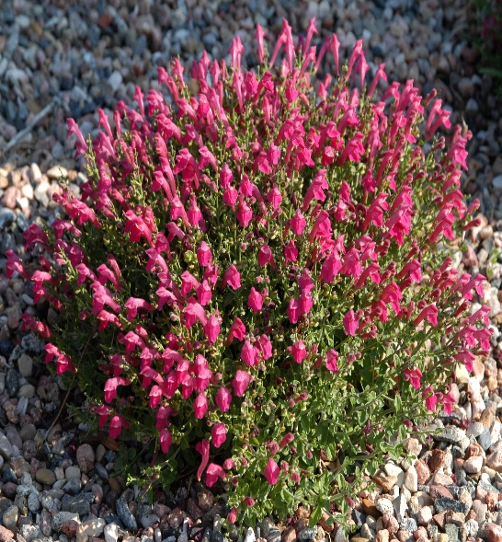

Height: 6-8 in. Width: 10-14 in.
Low mounding subshrub with continuous display of hot, cherry-red flowers. Grows best in sunny, well-drained sites. Good in raised beds, rock gardens, or in front of the border.
Culture: Loam, sandy or amended clay soil
Hardiness: USDA zones 6-9
(protected sites zone 5a)



WIND. HAIL. SNOW. SUN
BRING IT ON

www.plantselect.org



