

**Cherry Skullcap**

*Scutellaria suffrutescens*

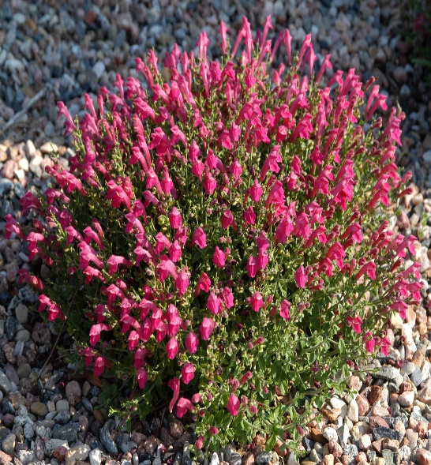

**Height: 6-8 in. Width: 10-14 in.**

Low mounding subshrub with continuous display of hot, cherry-red flowers. Grows best in sunny, well-drained sites. Good in raised beds, rock gardens, or in front of the border.

**Culture:** Loam, sandy or amended clay soil

**Hardiness:** USDA zones 6-9

(protected sites zone 5a)



WIND. HAIL. SNOW. SUN

**BRING IT ON**

www.plantselect.org

