

**Cherry Skullcap**

*Scutellaria suffrutescens*

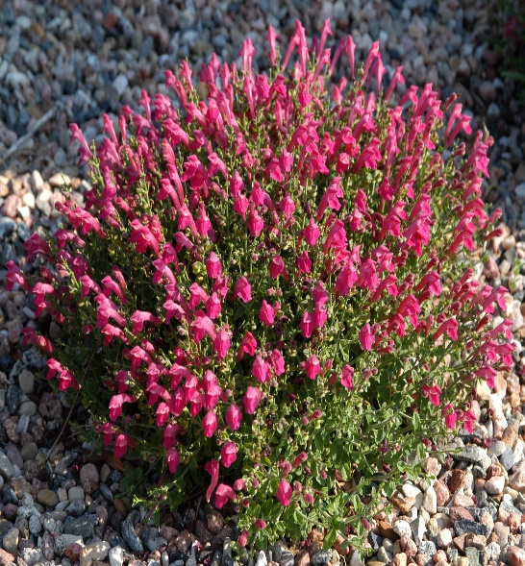

**Height: 3-8 in. Width: 10-15 in.**

Low mounding subshrub with continuous display of hot, cherry-red flowers. Grows best in sunny, well-drained sites. Good in raised beds, rock gardens, or in front of the border.

**Culture:** Clay, loam or sandy soil

**Hardiness:** USDA zones 6-9



WIND. HAIL. SNOW. SUN

**BRING IT ON**

www.plantselect.org

