
Smoky Hills Skullcap
Scutellaria resinosa ‘Smoky Hills’


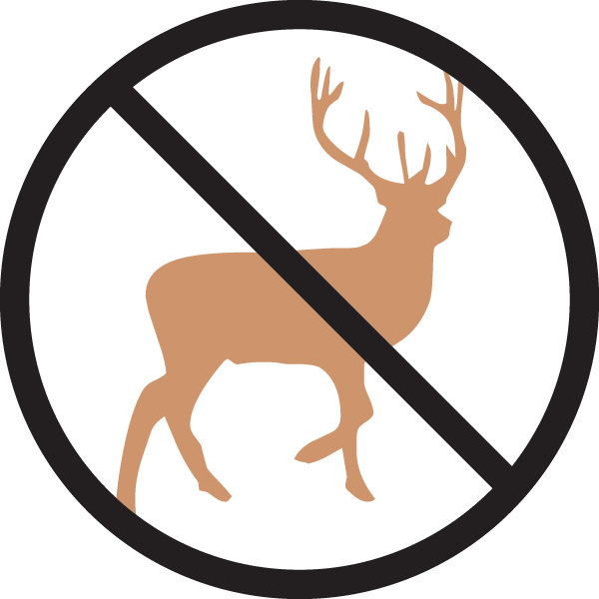


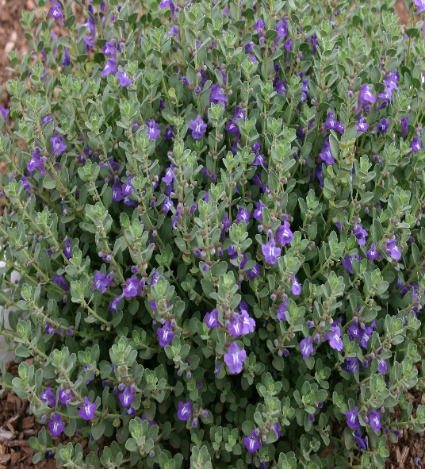


Height: 8-10 in. Width: 10-14 in.
Tidy mounds of greenish-grey leaves covered with bright purple-blue flowers tipped with white during early summer. Thrives in hot, sunny locations with well-drained soil. This durable shortgrass prairie native was named for the Smoky Hills of north central Kansas where it was first collected.
Culture: Loam or sandy soil
Hardiness: USDA zones 4-9



WIND. HAIL. SNOW. SUN
BRING IT ON

www.plantselect.org



