

**Smoky Hills Skullcap**

*Scutellaria resinosa ‘Smoky Hills’*

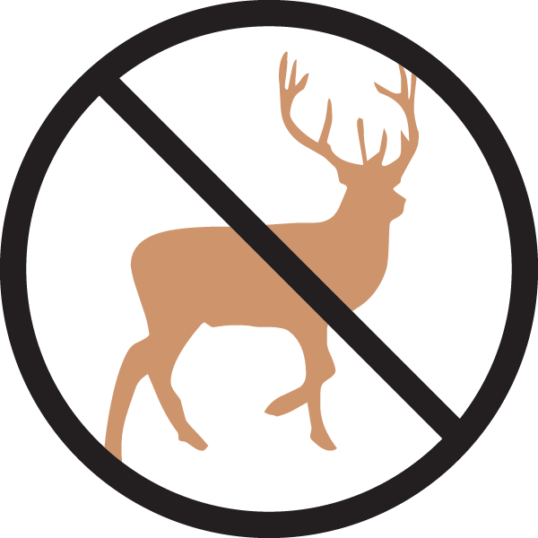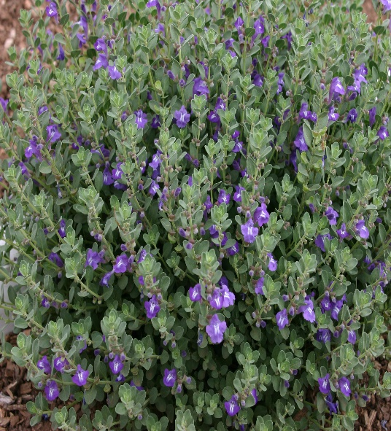

**Height: 8-10 in. Width: 10-14 in.**

Tidy mounds of greenish-grey leaves covered with bright purple-blue flowers tipped with white during early summer. Thrives in hot, sunny locations with well-drained soil. This durable shortgrass prairie native was named for the Smoky Hills of north central Kansas where it was first collected.

**Culture:** Loam or sandy soil

**Hardiness:** USDA zones 4-9



WIND. HAIL. SNOW. SUN

**BRING IT ON**

www.plantselect.org

