



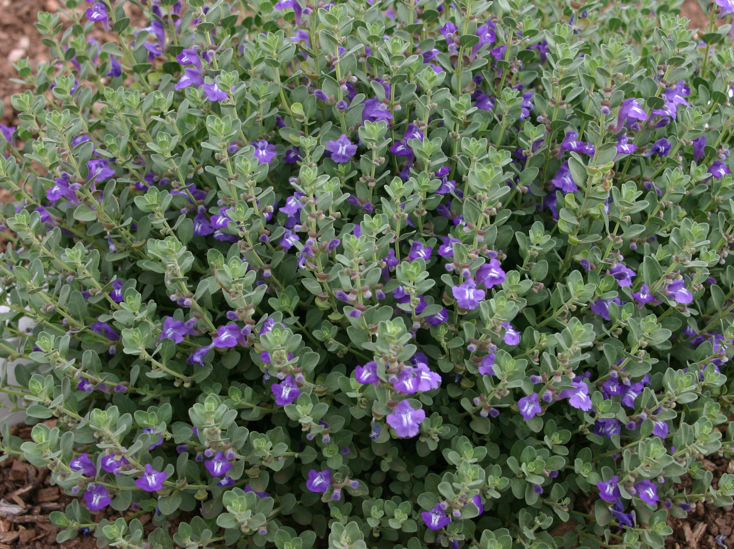
Height: 8-10”
Width: 10-14”
Blooms: Blue; summer
Sun: Full sun
Water: Dry to xeric
Hardiness: USDA zones 4-9
Culture: Loam or sandy soils
Recommended: 2014
Perennial
Tidy mounds of greenish-grey leaves covered with bright purple-blue flowers tipped with white during early summer. (Deadheading will provide new growth and bloom through fall.) Thrives in hot, sunny locations with well-drained soil. This durable shortgrass prairie native was named for the Smoky Hills of north central Kansas where it was first collected.

Smoky Hills Skullcap
Scutellaria resinosa ‘Smoky Hills’
www.plantselect.org

