


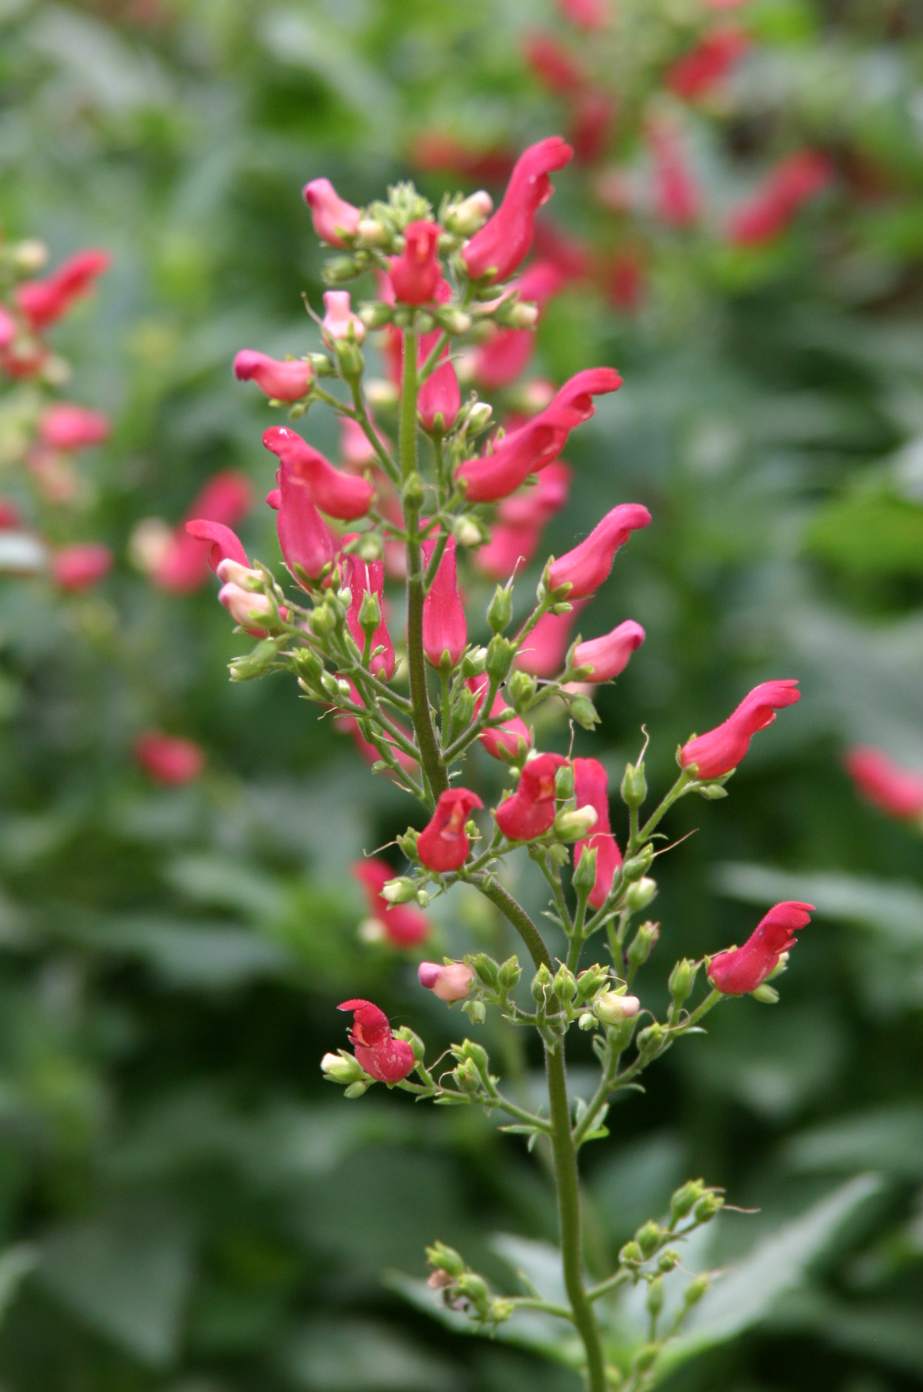
Height: 36”
Width: 18”
Blooms: May to frost
Sun: Full sun to partial shade
Water: Moderate to dry
Hardiness: USDA zones 4-9 (up to 8,000’)
Culture: Sandy, clay, or loamy soil
Recommended: 2008
Perennial
Introduced in 1996 by High Country Gardens, this rare penstemon cousin has showy crimson tubular flowers which are produced in generous sprays above rich green serrated foliage. This southwestern uplands wildflower has shown great adaptability in gardens.

Red Birds in a Tree
Scrophularia macrantha
www.plantselect.org

