
Red Birds in a Tree
Scrophularia macrantha






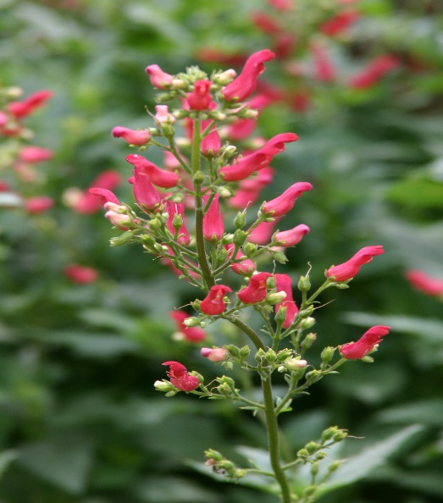

Height: 24-36 in. Width: 16-20 in.
Introduced in 1996 by High Country Gardens, this rare penstemon cousin has showy crimson tubular flowers which are produced in generous sprays above rich green serrated foliage. This southwestern uplands wildflower has shown great adaptability in gardens. Blooms May to frost.
Culture: Clay, loam or sandy soil
Hardiness: USDA zones 4-9



WIND. HAIL. SNOW. SUN
BRING IT ON

www.plantselect.org



