

**Red Birds in a Tree**

*Scrophularia macrantha*

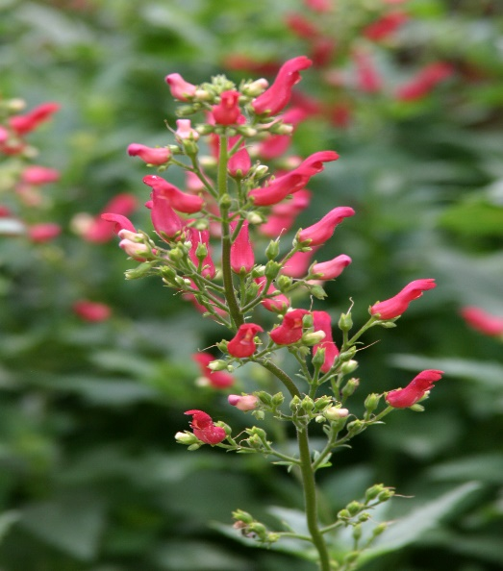

**Height: 24-36 in. Width: 16-20 in.**

Introduced in 1996 by High Country Gardens, this rare penstemon cousin has showy crimson tubular flowers which are produced in generous sprays above rich green serrated foliage. This southwestern uplands wildflower has shown great adaptability in gardens. Blooms May to frost.

**Culture:** Clay, loam or sandy soil

**Hardiness:** USDA zones 4-9



WIND. HAIL. SNOW. SUN

**BRING IT ON**

www.plantselect.org

