
Standing Ovation little bluestem
Schizachyrium scoparium ‘Standing Ovation’ ^{PP25,202}




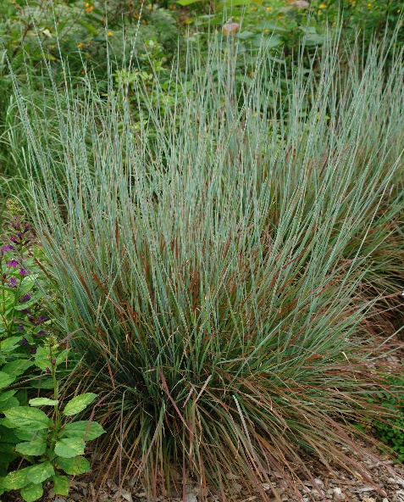


Height: 2-3 ft. Width: 15-18 in.
A warm-season grass that does well in poor, dry soils. Mounds of bluish-green leaves transition to brilliant shades of red and deep purple in autumn. Seed heads remain upright though winter providing interest and food for birds.
Culture: Adaptable
Hardiness: USDA zones 3-8



WIND. HAIL. SNOW. SUN
BRING IT ON

www.plantselect.org



