

**Standing Ovation little bluestem**

*Schizachyrium scoparium ‘Standing Ovation’ PP25,202*

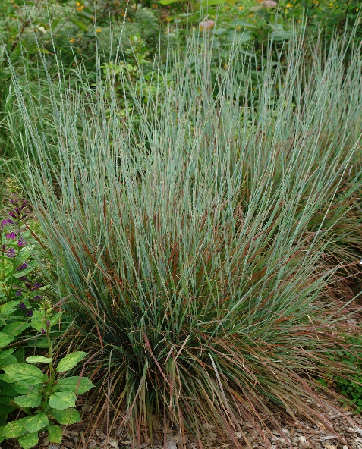

**Height: 2-3 ft. Width: 15-18 in.**

A warm-season grass that does well in poor, dry soils. Mounds of bluish-green leaves transition to brilliant shades of red and deep purple in autumn. Seed heads remain upright though winter providing interest and food for birds.

**Culture:** Adaptable

**Hardiness:** USDA zones 3-8



WIND. HAIL. SNOW. SUN

**BRING IT ON**

www.plantselect.org

