
Purple Winter Savory
Satureja montana var. illyrica




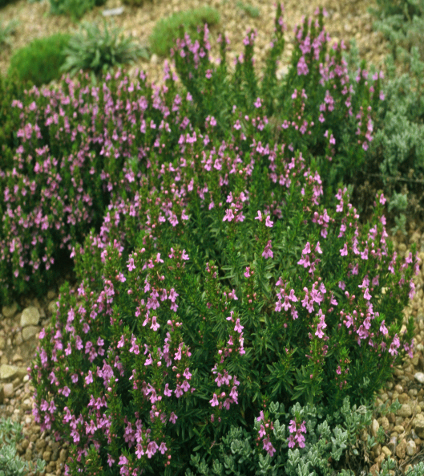





Height: 4-6 in. Width: 12-15 in.
Purple-blue flowered, prostrate form of the popular garden herb. Trim evergreen mounds covered with showy flowers late in the season.
Culture: Clay, loam or sandy soil
Hardiness: USDA zones 3-8



WIND. HAIL. SNOW. SUN
BRING IT ON

www.plantselect.org



