

**Purple Winter Savory**

*Satureja montana* var. *illyrica*

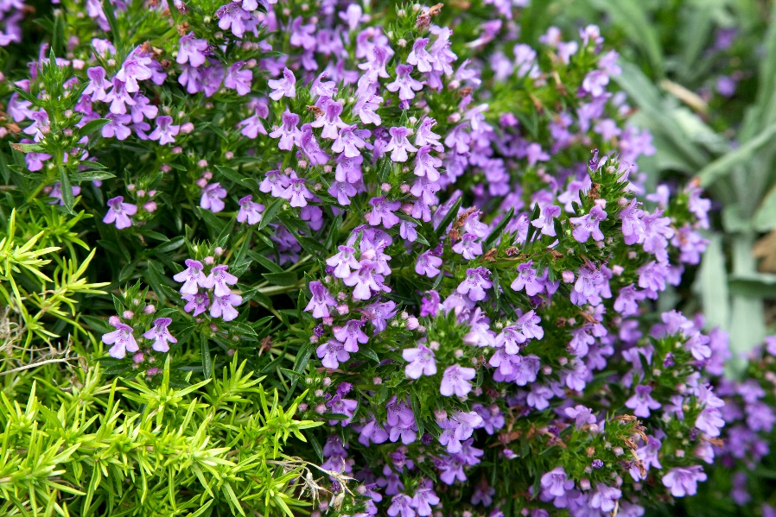



**Height: 4-6 in. Width: 14-16 in.**

Purple-blue flowered, prostrate form of the popular garden herb. Trim evergreen mounds covered with showy flowers late in the season.

**Culture:** Clay, loam or sandy soil

**Hardiness:** USDA zones 3b-8



WIND. HAIL. SNOW. SUN

**BRING IT ON**

www.plantselect.org

