


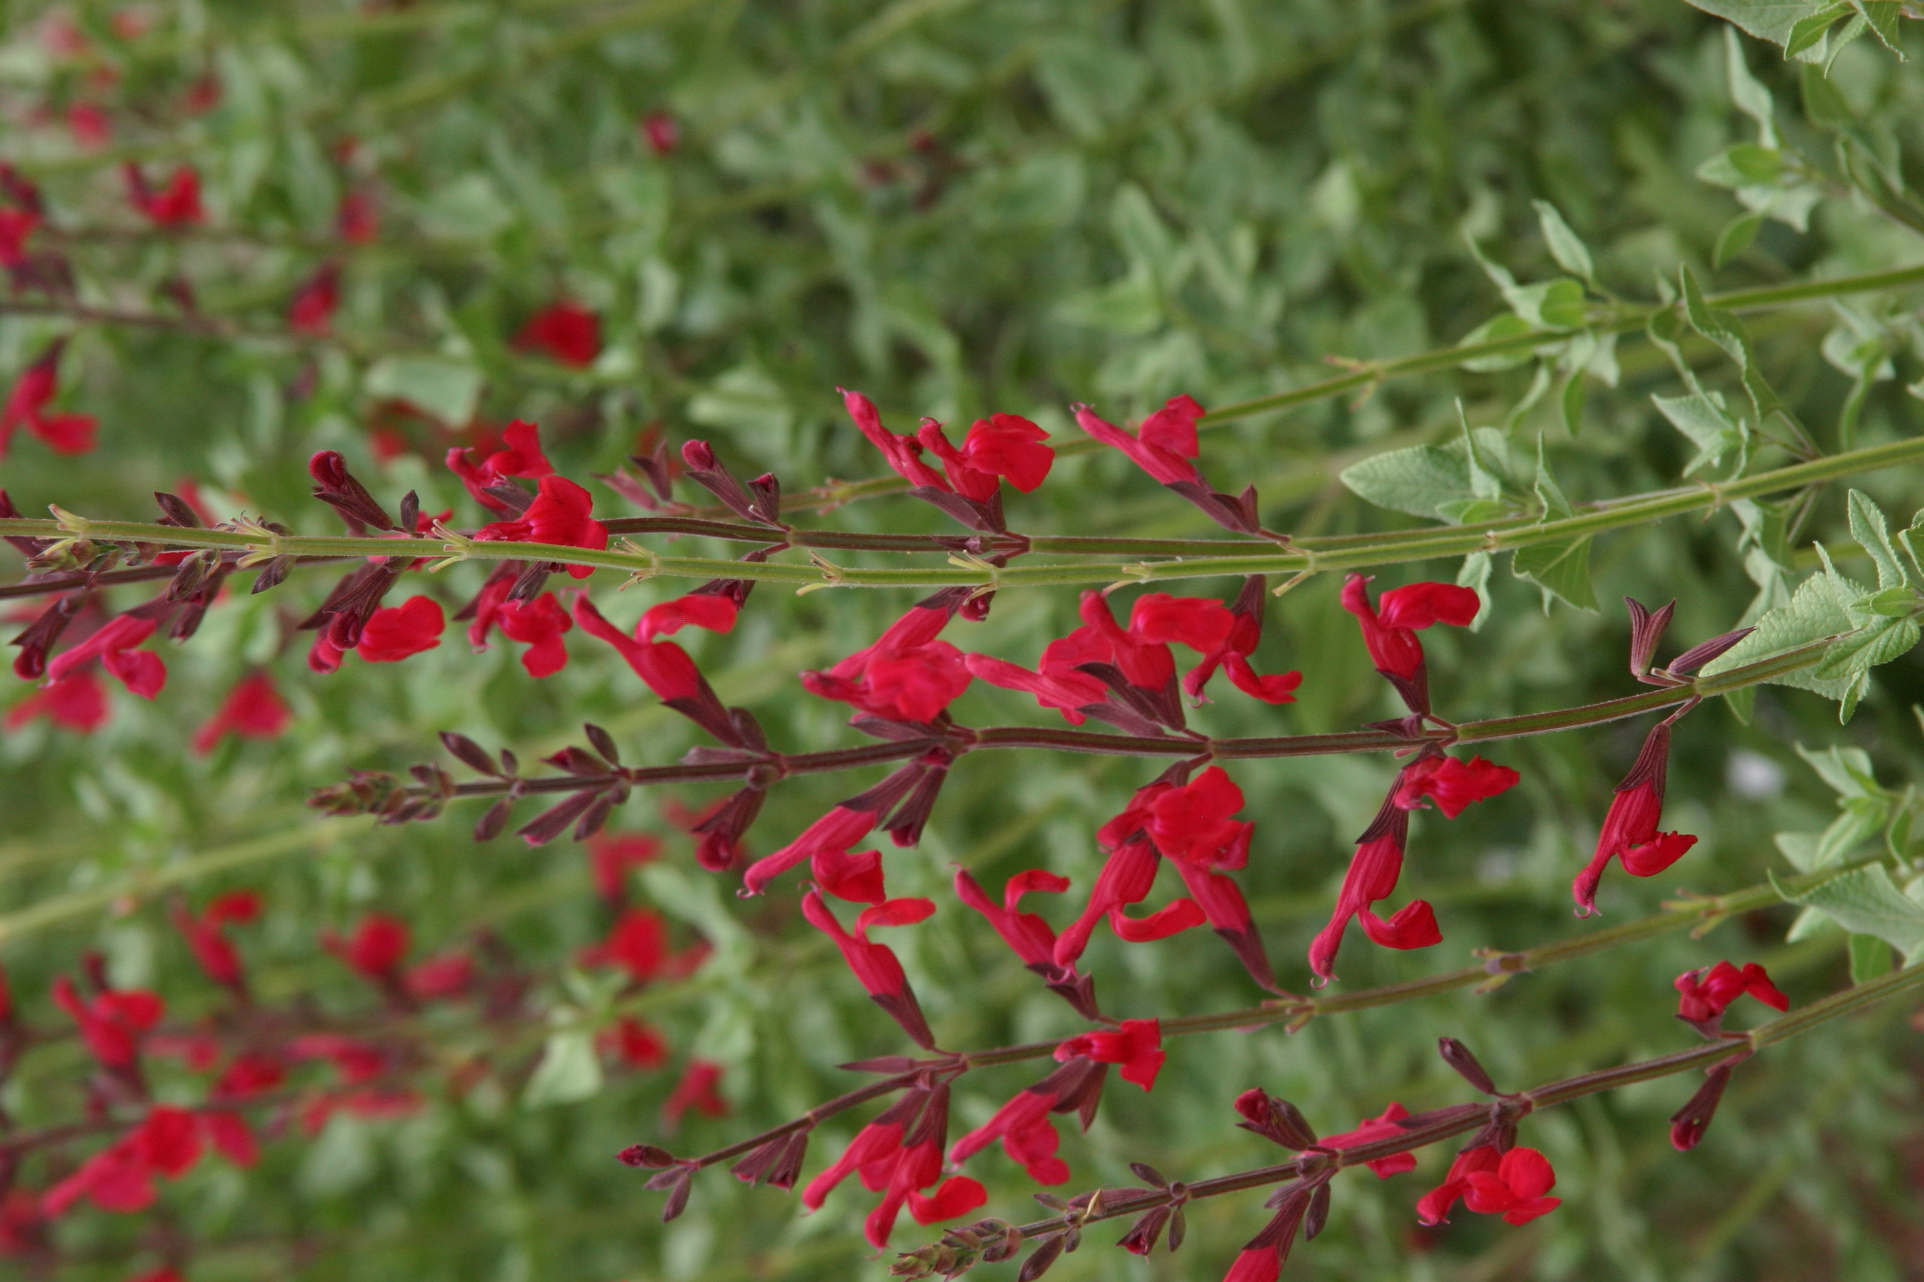

Height: 36-48”
Width: 48”
Blooms: Blood red, late June through October
Sun: Full sun
Water: Moderate to xeric
Hardiness: USDA zones 5-9
Culture: Clay, loam or sand
Recommended: 2015
Perennial
While hummingbirds LOVE this perennial, deer struggle to harm this hardy plant. WINDWALKER® royal red salvia is a robust grower with graceful stems crowned with blood-red flowers from late June through October. Beautiful planted with WINDWALKER® big bluestem grass. Can be cut back in early summer to reduce ultimate height.

Windwalker® royal red salvia
Salvia darcyi x S. microphylla ‘PWIN03S’
www.plantselect.org

