

**Ultra Violet Salvia**

*Salvia ‘Ultra Violet’PP21,411*

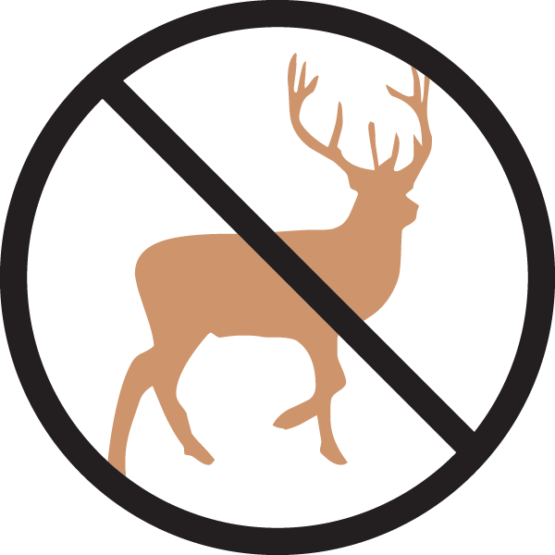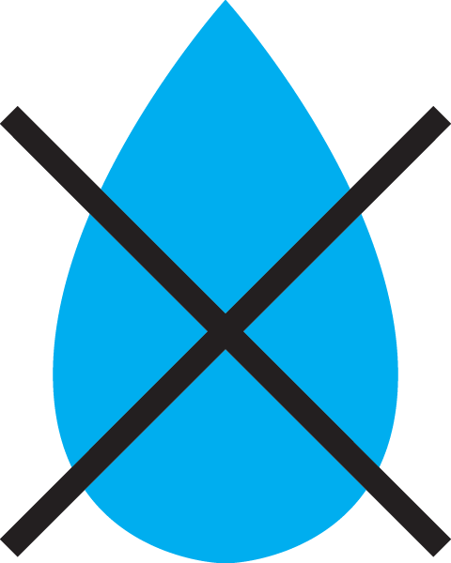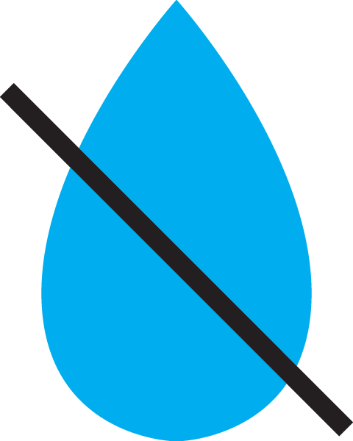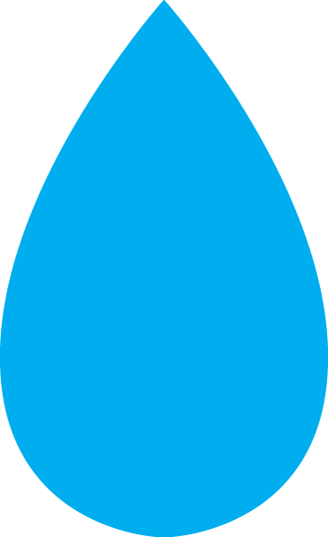

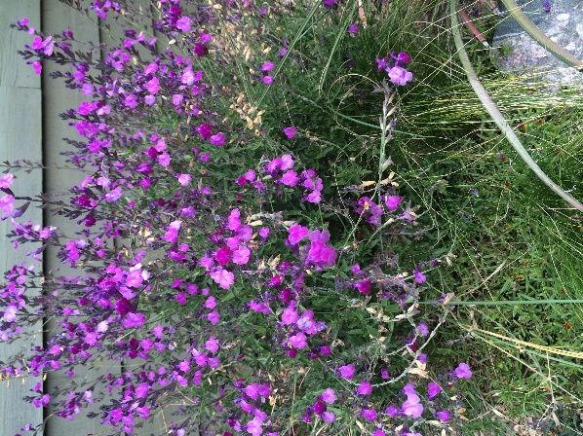

**Height: 18-24 in. Width: 18-24 in.**

An exciting salvia exhibiting a compact and floriferous habit with an unusually iridescent deep purple flower. It is both more compact and hardier than so many of the *Salvia greggii* types that are on the market. A top perennial for dry sites that establishes easily in the garden!

**Culture:** Well-drained soil

**Hardiness:** USDA zones 5-9



WIND. HAIL. SNOW. SUN

**BRING IT ON**

www.plantselect.org

