


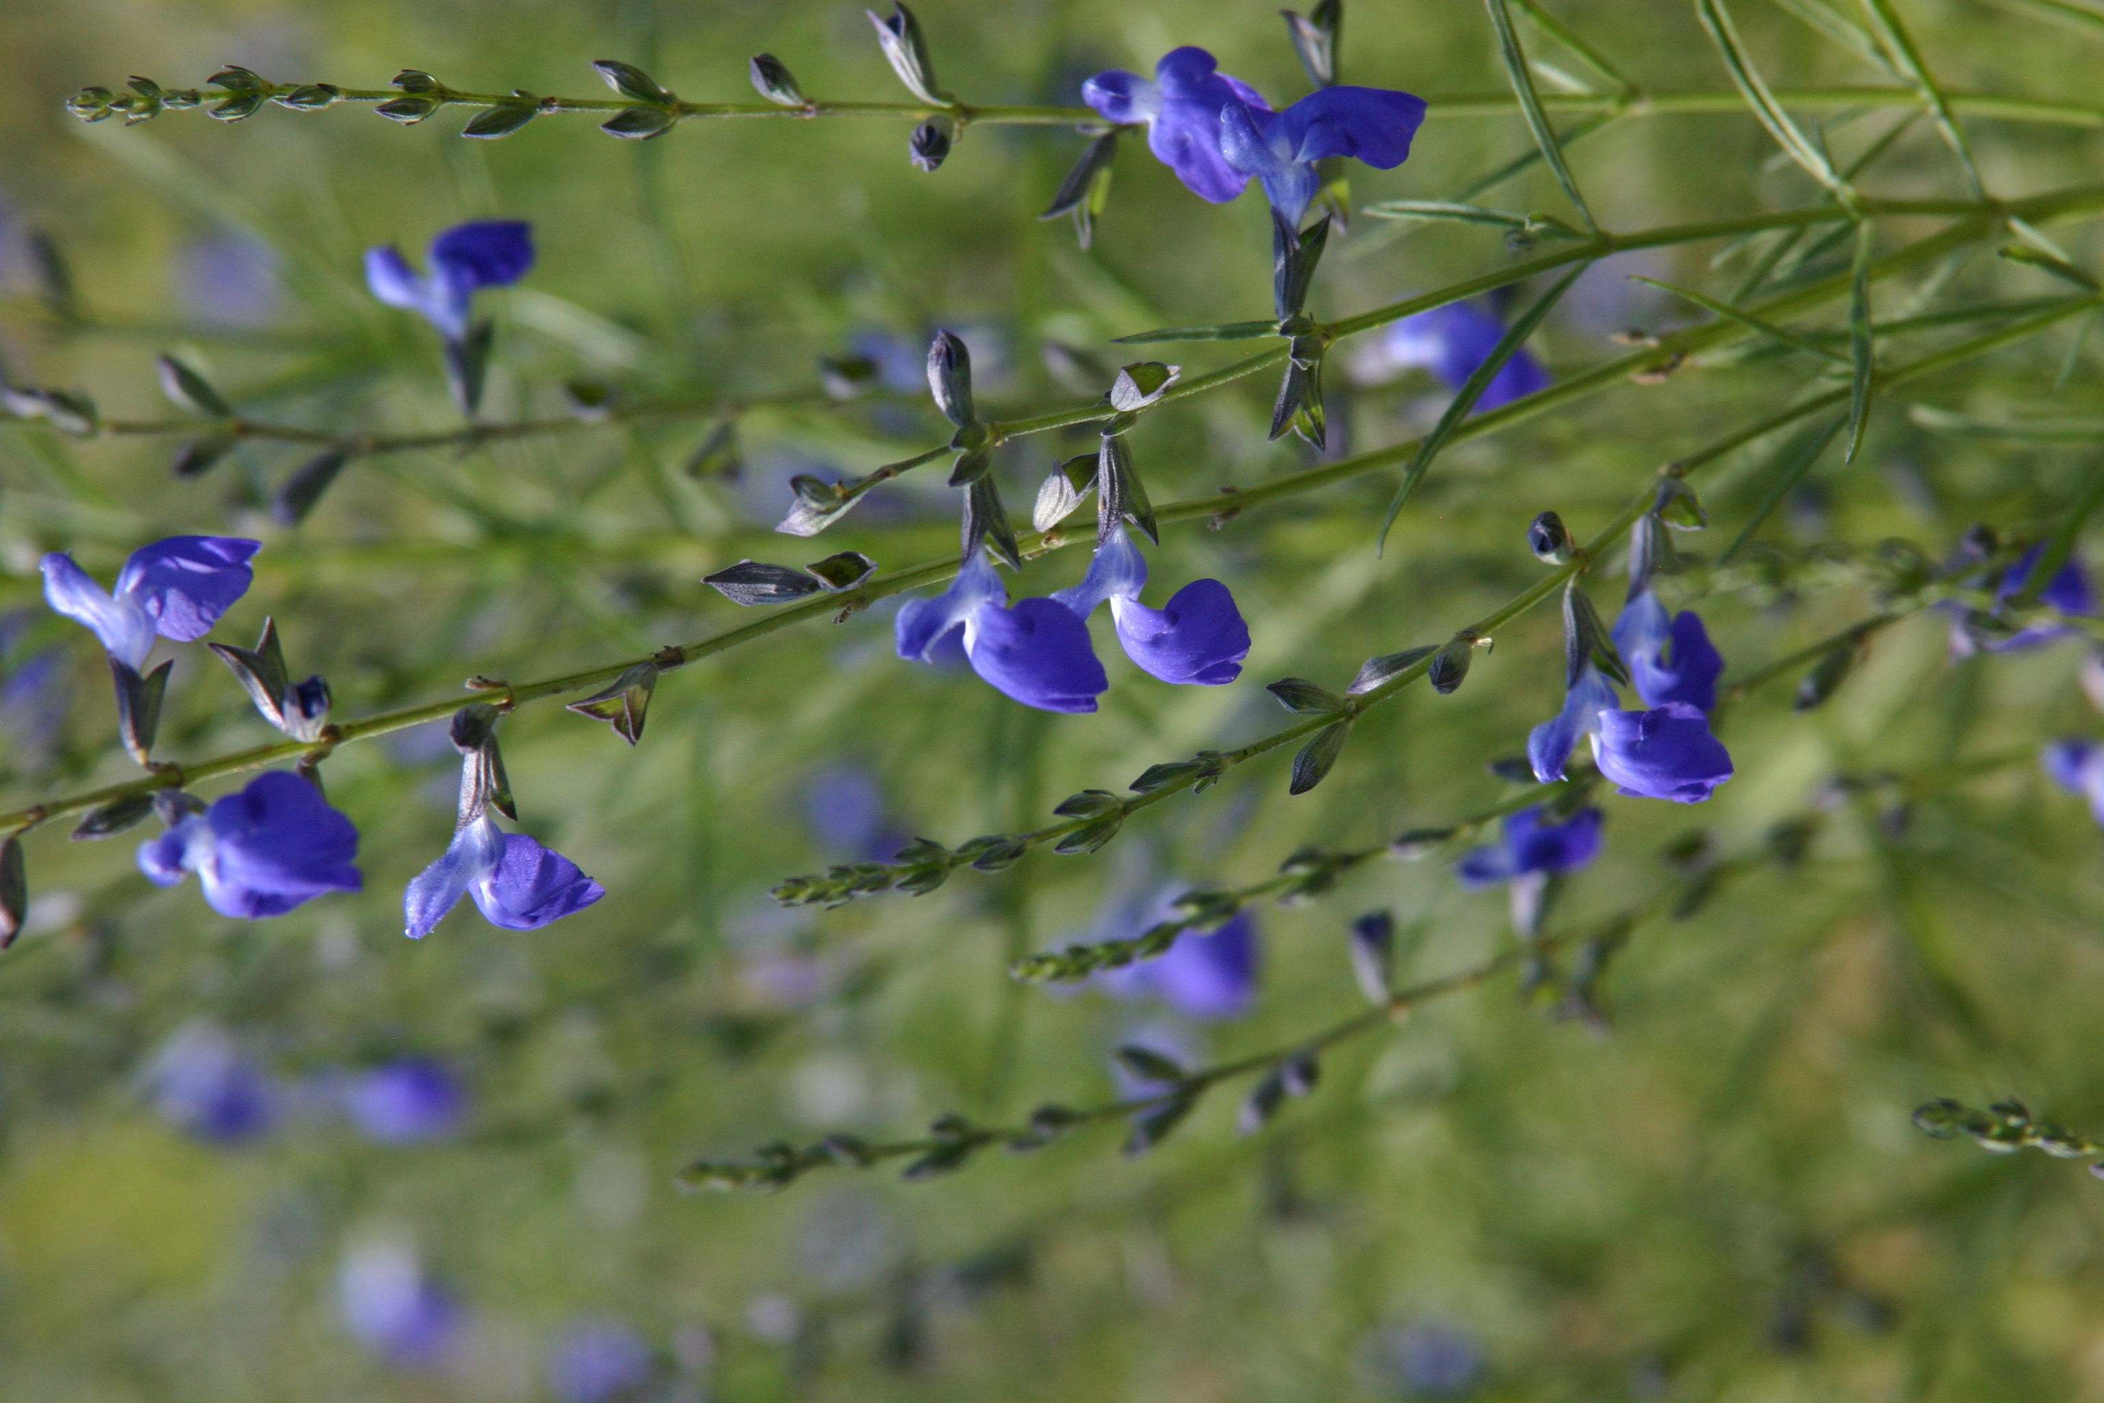




Height: 18-24”
Width: 18-24”
Blooms: Autumn
Sun: Full sun
Water: Dry to xeric
Hardiness: USDA zones 5-10
Culture: Well drained, sandy soil
Introduced: 2016
Perennial
This superior form of West Texas sage was chosen from trials for its compact and consistent growth habitat. Glossy green, willowy leaves all season long are topped with clouds of small, sapphire-blue flowers through autumn.

Autumn Sapphire™ sage
Salvia reptans ‘P016S’
www.plantselect.org

