
Autumn Sapphire® sage
Salvia reptans ‘P016S’



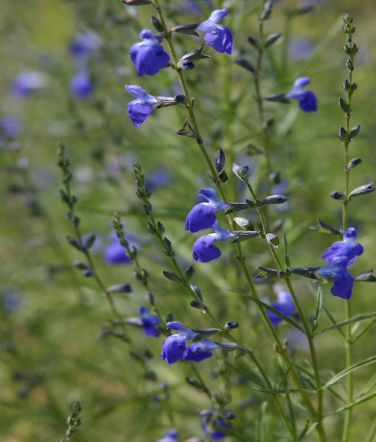




Height: 18-24 in. Width: 18-24 in.
This superior form of West Texas sage was chosen for its compact and consistent growth habit. Glossy green, willowy leaves all season long are topped with clouds of small, sapphire-blue flowers through autumn. An excellent addition to water-wise gardens.
Culture: Well-drained, sandy soil
Hardiness: USDA zones 5-10



WIND. HAIL. SNOW. SUN
BRING IT ON

www.plantselect.org



