

**Autumn Sapphire® sage**

*Salvia reptans ‘P016S’*

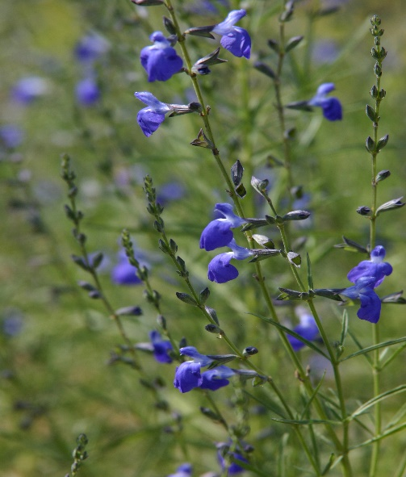

**Height: 18-24 in. Width: 18-24 in.**

This superior form of West Texas sage was chosen for its compact and consistent growth habit. Glossy green, willowy leaves all season long are topped with clouds of small, sapphire-blue flowers through autumn. An excellent addition to water-wise gardens.

**Culture:** Well-drained, sandy soil

**Hardiness:** USDA zones 5-10



WIND. HAIL. SNOW. SUN

**BRING IT ON**

www.plantselect.org

