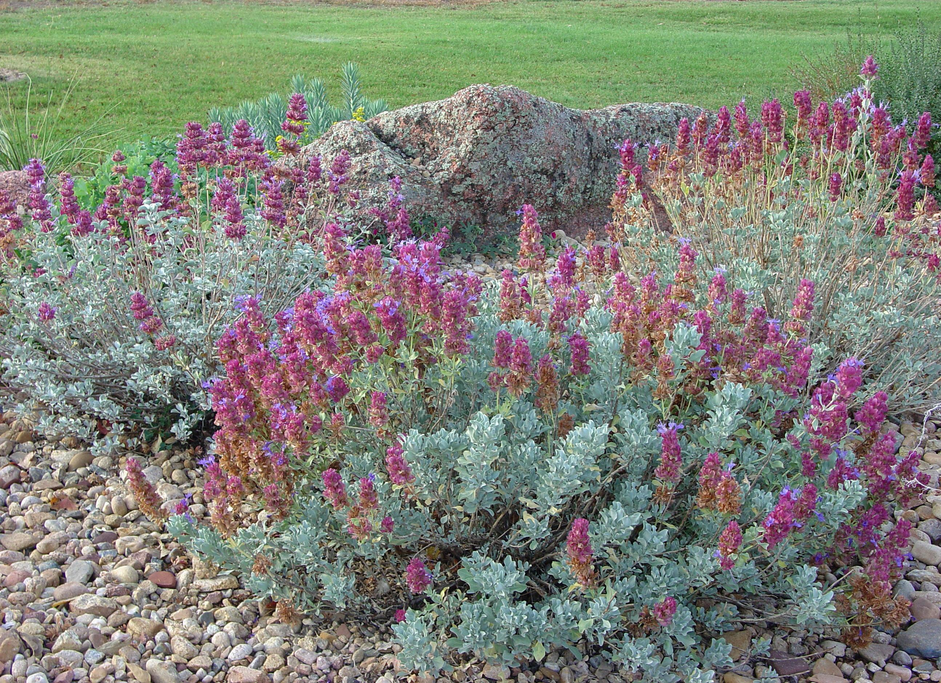




Height: 18-36”
Width: 24-36”
Blooms: June to November
Sun: Full sun
Water: Moderate to xeric
Hardiness: USDA zones 5-10
Culture: Average or sandy soil with good drainage
Introduced: 2005
Shrubby perennial
The intensely aromatic, evergreen foliage is eye-catching. Silver-green leaves set off persistent mauve bracts that surround the flowers.

Mojave Sage
Salvia pachyphylla
www.plantselect.org

