
Mojave Sage
Salvia pachyphylla


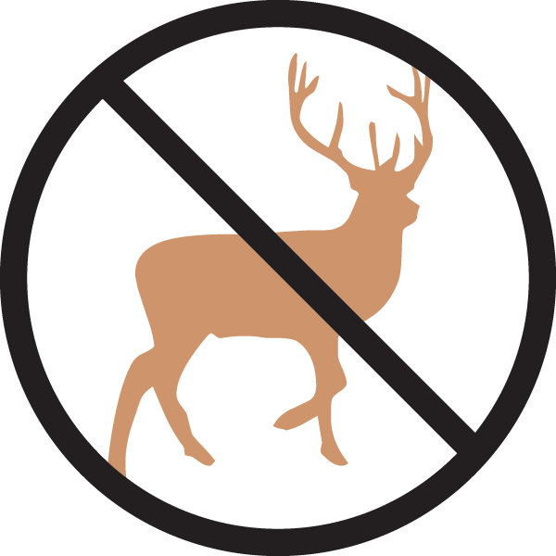

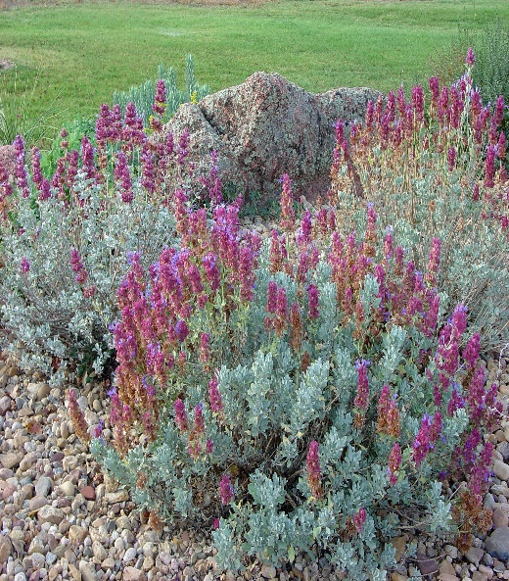





Height: 18-36 in. Width: 24-36 in.
The intensely aromatic, evergreen foliage is eye-catching. Silver-green leaves set off persistent mauve bracts that surround the flowers. Western native.
Culture: Loam or sandy soil
Hardiness: USDA zones 5-10



WIND. HAIL. SNOW. SUN
BRING IT ON

www.plantselect.org



