

**Mojave Sage**

*Salvia pachyphylla*

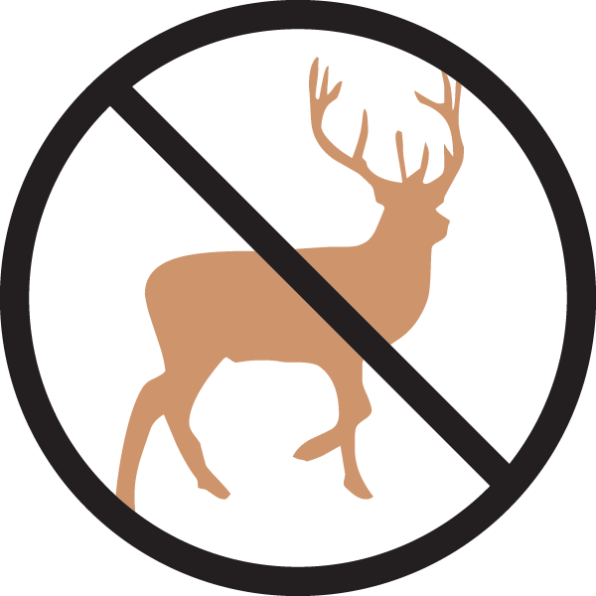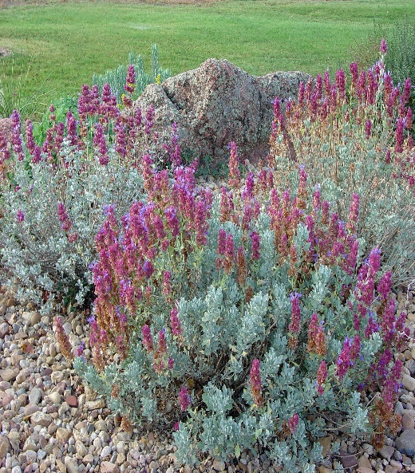

**Height: 18-36 in. Width: 24-36 in.**

The intensely aromatic, evergreen foliage is eye-catching. Silver-green leaves set off persistent mauve bracts that surround the flowers. Western native.

**Culture:** Loam or sandy soil

**Hardiness:** USDA zones 5-10



WIND. HAIL. SNOW. SUN

**BRING IT ON**

www.plantselect.org

