
Wild Thing Sage
Salvia greggi






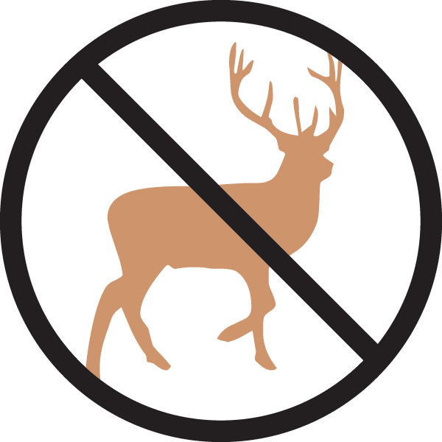

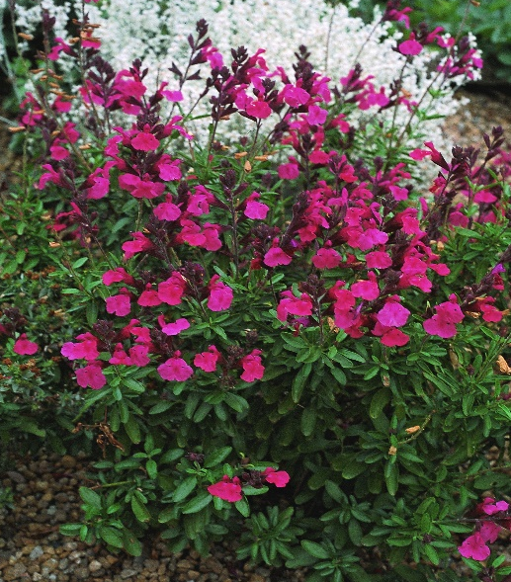

Height: 18-24 in. Width: 18-24 in.
Aromatic mounds of dark, semi-evergreen foliage are covered with flushes of hot pink flowers much of the growing season. Brought to Plant Select® by Tom Peace. Best cut back in spring.
Culture: Loam, sandy or amended clay soil
Hardiness: USDA zones 5b-10



WIND. HAIL. SNOW. SUN
BRING IT ON

www.plantselect.org



