

**Furman’s Red Sage**

*Salvia greggi* ‘Furman’s Red’

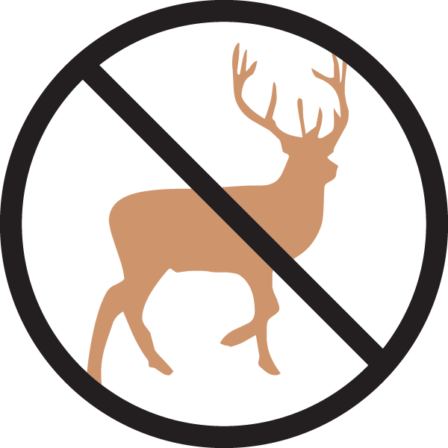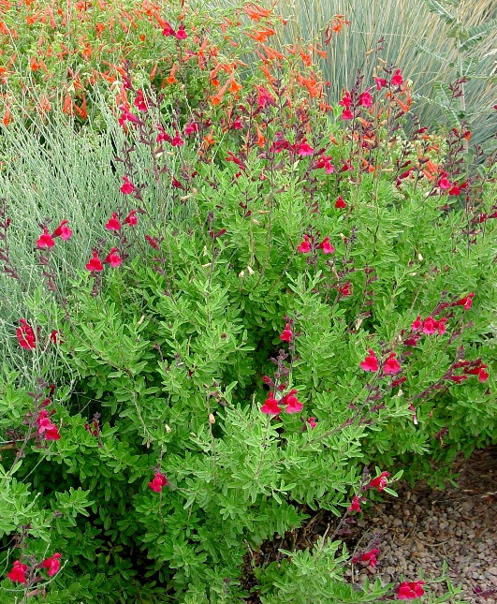

**Height: 18-24 in. Width: 18-24 in.**

Hardy selection of a southwestern, ever blooming sage. Crimson to scarlet flowers are produced in repeated flushes through the summer and autumn. Best cut back in spring.

**Culture:** Loam, sandy or amended clay soil

**Hardiness:** USDA zones 5b-10



WIND. HAIL. SNOW. SUN

**BRING IT ON**

www.plantselect.org

