

**Furman’s Red Sage**

*Salvia greggi* ‘Furman’s Red’

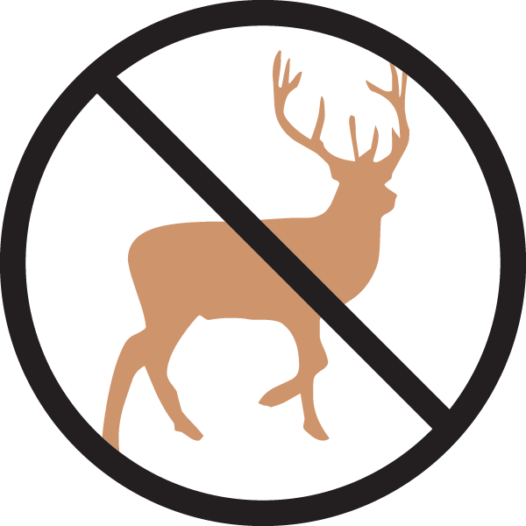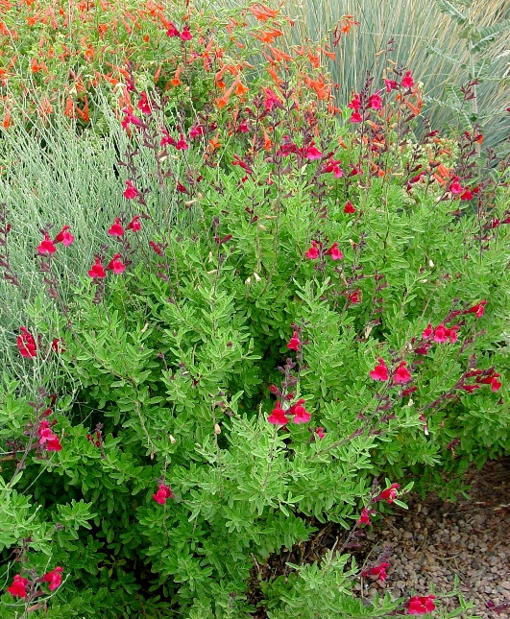

**Height: 18-24 in. Width: 12-14 in.**

Hardy selection of a southwestern, ever blooming sage. Crimson to scarlet flowers are produced in repeated flushes through the summer and autumn. Best cut back in spring.

**Culture:** Clay, loam or sandy soil

**Hardiness:** USDA zones 5-10



WIND. HAIL. SNOW. SUN

**BRING IT ON**

www.plantselect.org

