

**Wild Thing Sage**

*Salvia greggi*

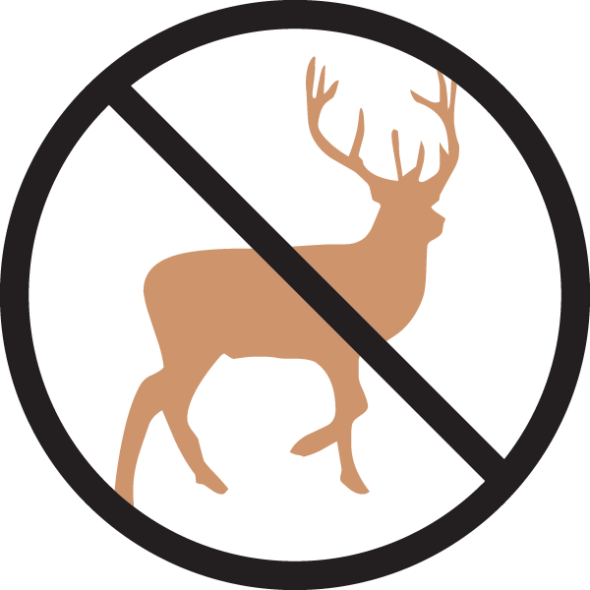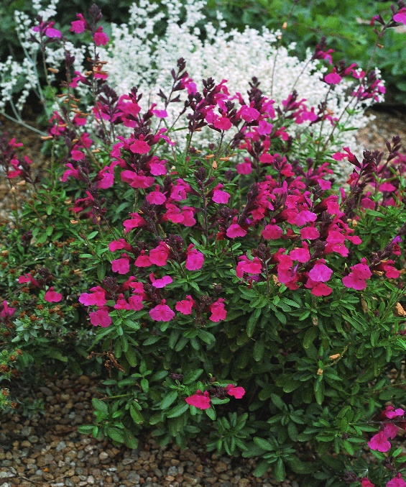

**Height: 16-20 in. Width: 12-14 in.**

Aromatic mounds of dark, semi-evergreen foliage are covered with flushes of hot pink flowers much of the growing season. Brought to Plant Select® by Tom Peace. Best cut back in spring.

**Culture:** Clay, loam or sandy soil

**Hardiness:** USDA zones 5-10



WIND. HAIL. SNOW. SUN

**BRING IT ON**

www.plantselect.org

