
Windwalker® royal red salvia
Salvia darcyi x S. microphylla

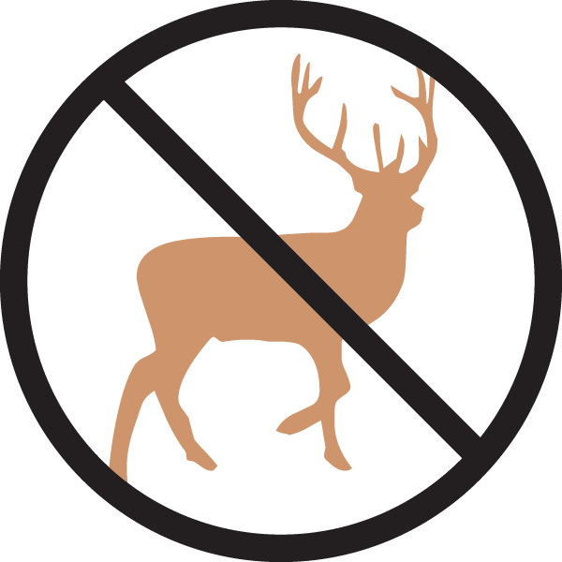





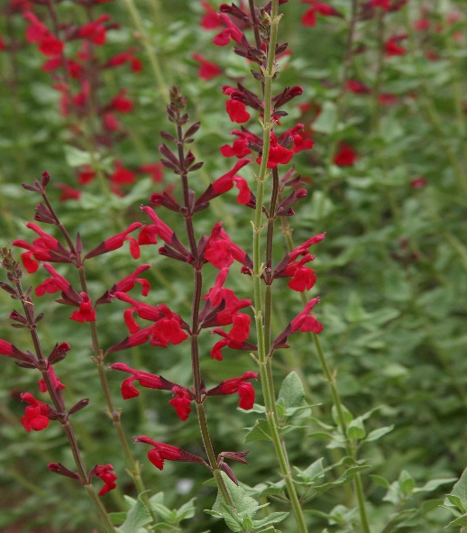

Height: 46-50 in. Width: 46-50 in.
Hummingbirds LOVE this new perennial salvia. Its graceful stems are crowned with blood-red flowers from late June through October. Can be cut back in early summer to reduce ultimate height if desired.
Culture: Clay, loam, or sandy soils
Hardiness: USDA zones 5-9



WIND. HAIL. SNOW. SUN
BRING IT ON

www.plantselect.org



