

**Windwalker® royal red salvia**

*Salvia darcyi x S. microphylla*

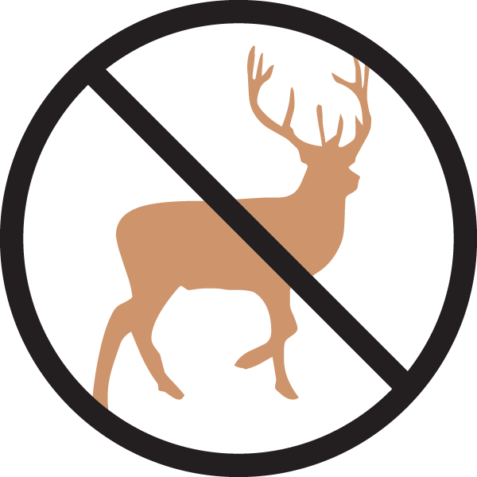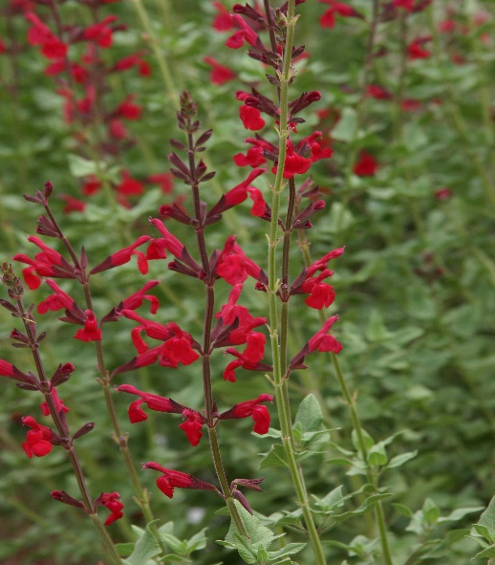

**Height: 46-50 in. Width: 46-50 in.**

Hummingbirds LOVE this new perennial salvia. Its graceful stems are crowned with blood-red flowers from late June through October. Can be cut back in early summer to reduce ultimate height if desired.

**Culture:** Clay, loam, or sandy soils

**Hardiness:** USDA zones 5-9



WIND. HAIL. SNOW. SUN

**BRING IT ON**

www.plantselect.org

