

**Vermillion Bluffs® Mexican Sage**

*Salvia darcyi ‘Pscarl’*

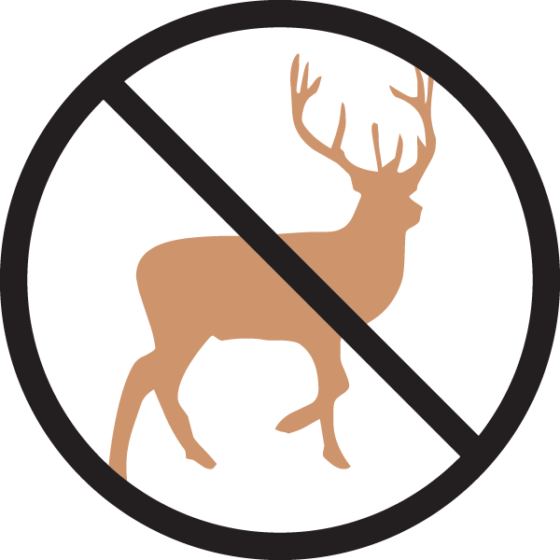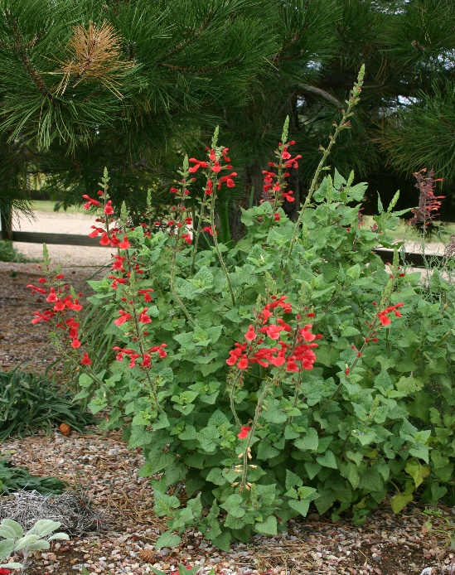

**Height: 36-40 in. Width: 28-32 in.**

Brilliant cardinal-red spires in late summer and fall attract hummingbirds. It has proven hardy under protected conditions in Denver since 2002.

**Culture:** Loam

**Hardiness:** USDA zones 5b-10



WIND. HAIL. SNOW. SUN

**BRING IT ON**

www.plantselect.org

