
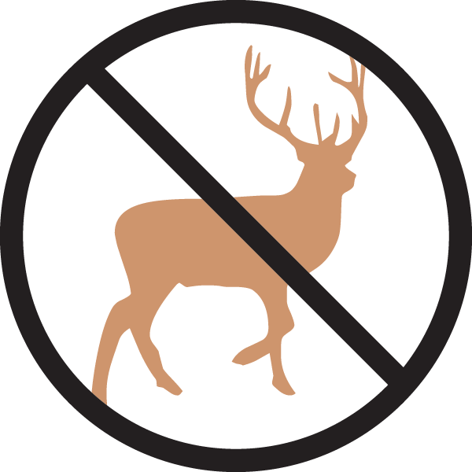


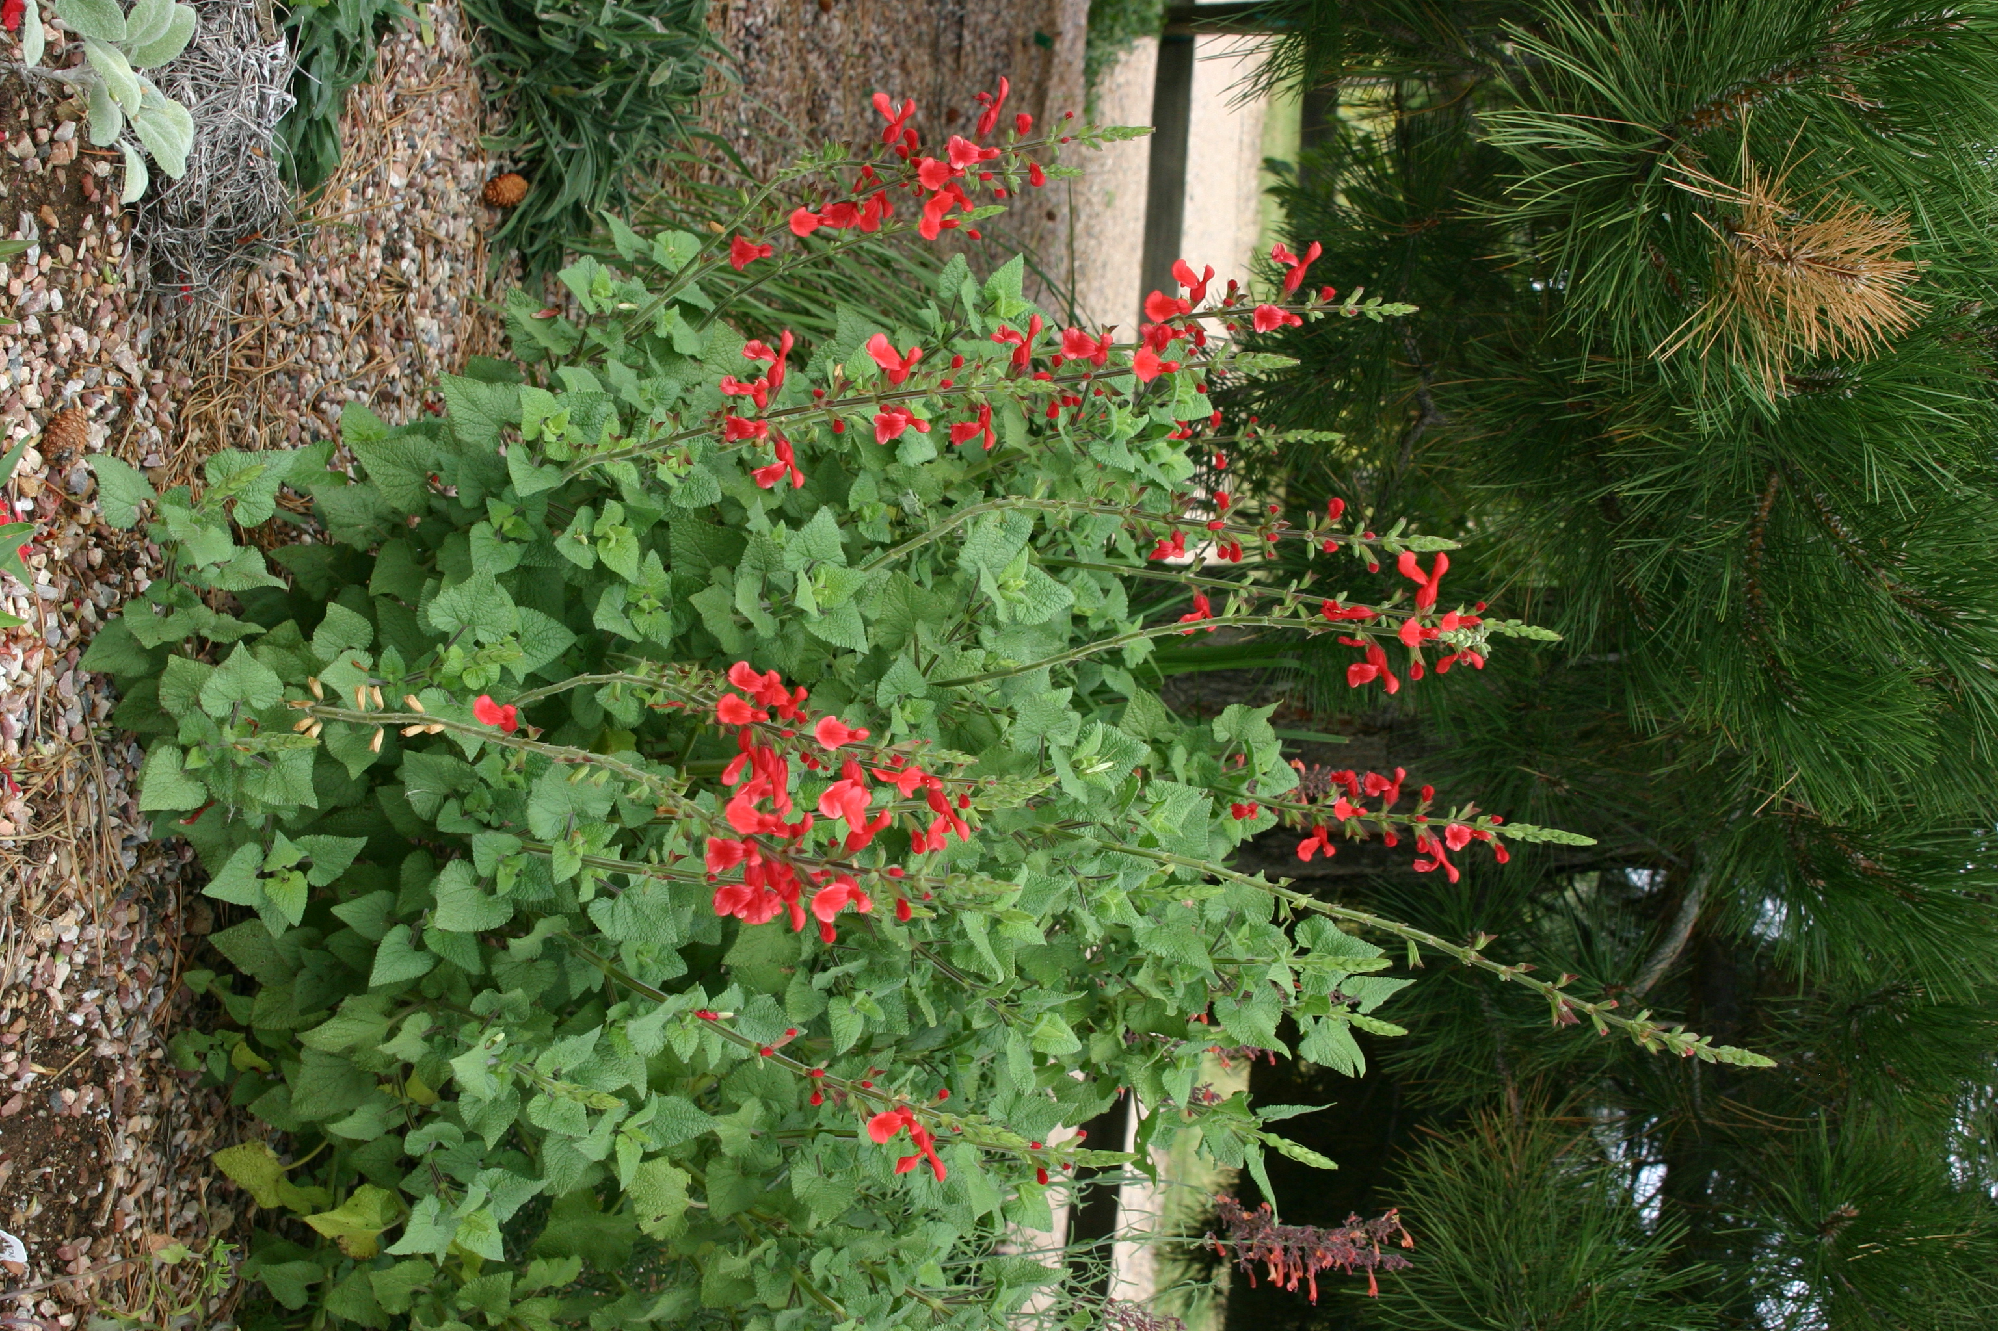
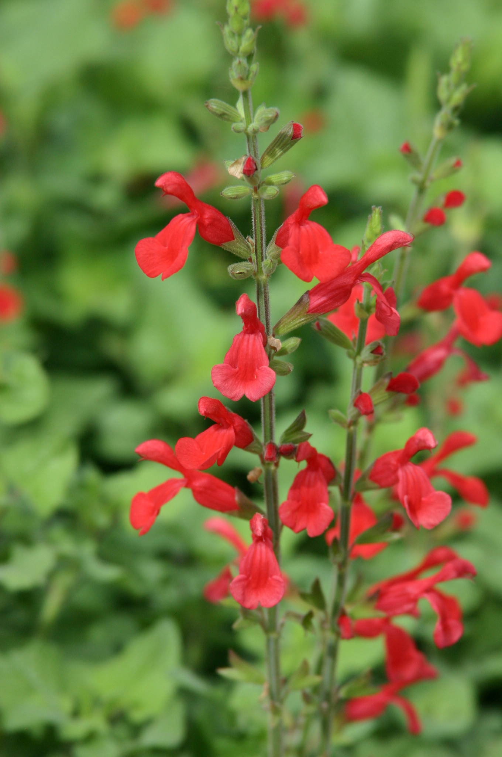
Height: 35-40”
Width: 20-30”
Blooms: August to October
Sun: Full sun to partial shade
Water: Moderate
Hardiness: USDA zones 5b-10 (up to 5,500’)
Culture: Loamy garden soil
Introduced: 2007
Perennial
Brilliant cardinal-red spires in late summer and fall attract hummingbirds. It has proven hardy under protected conditions in Denver since 2002.

Vermillion Bluffs® Mexican Sage
Salvia darcyi ‘Pscarl’
www.plantselect.org

