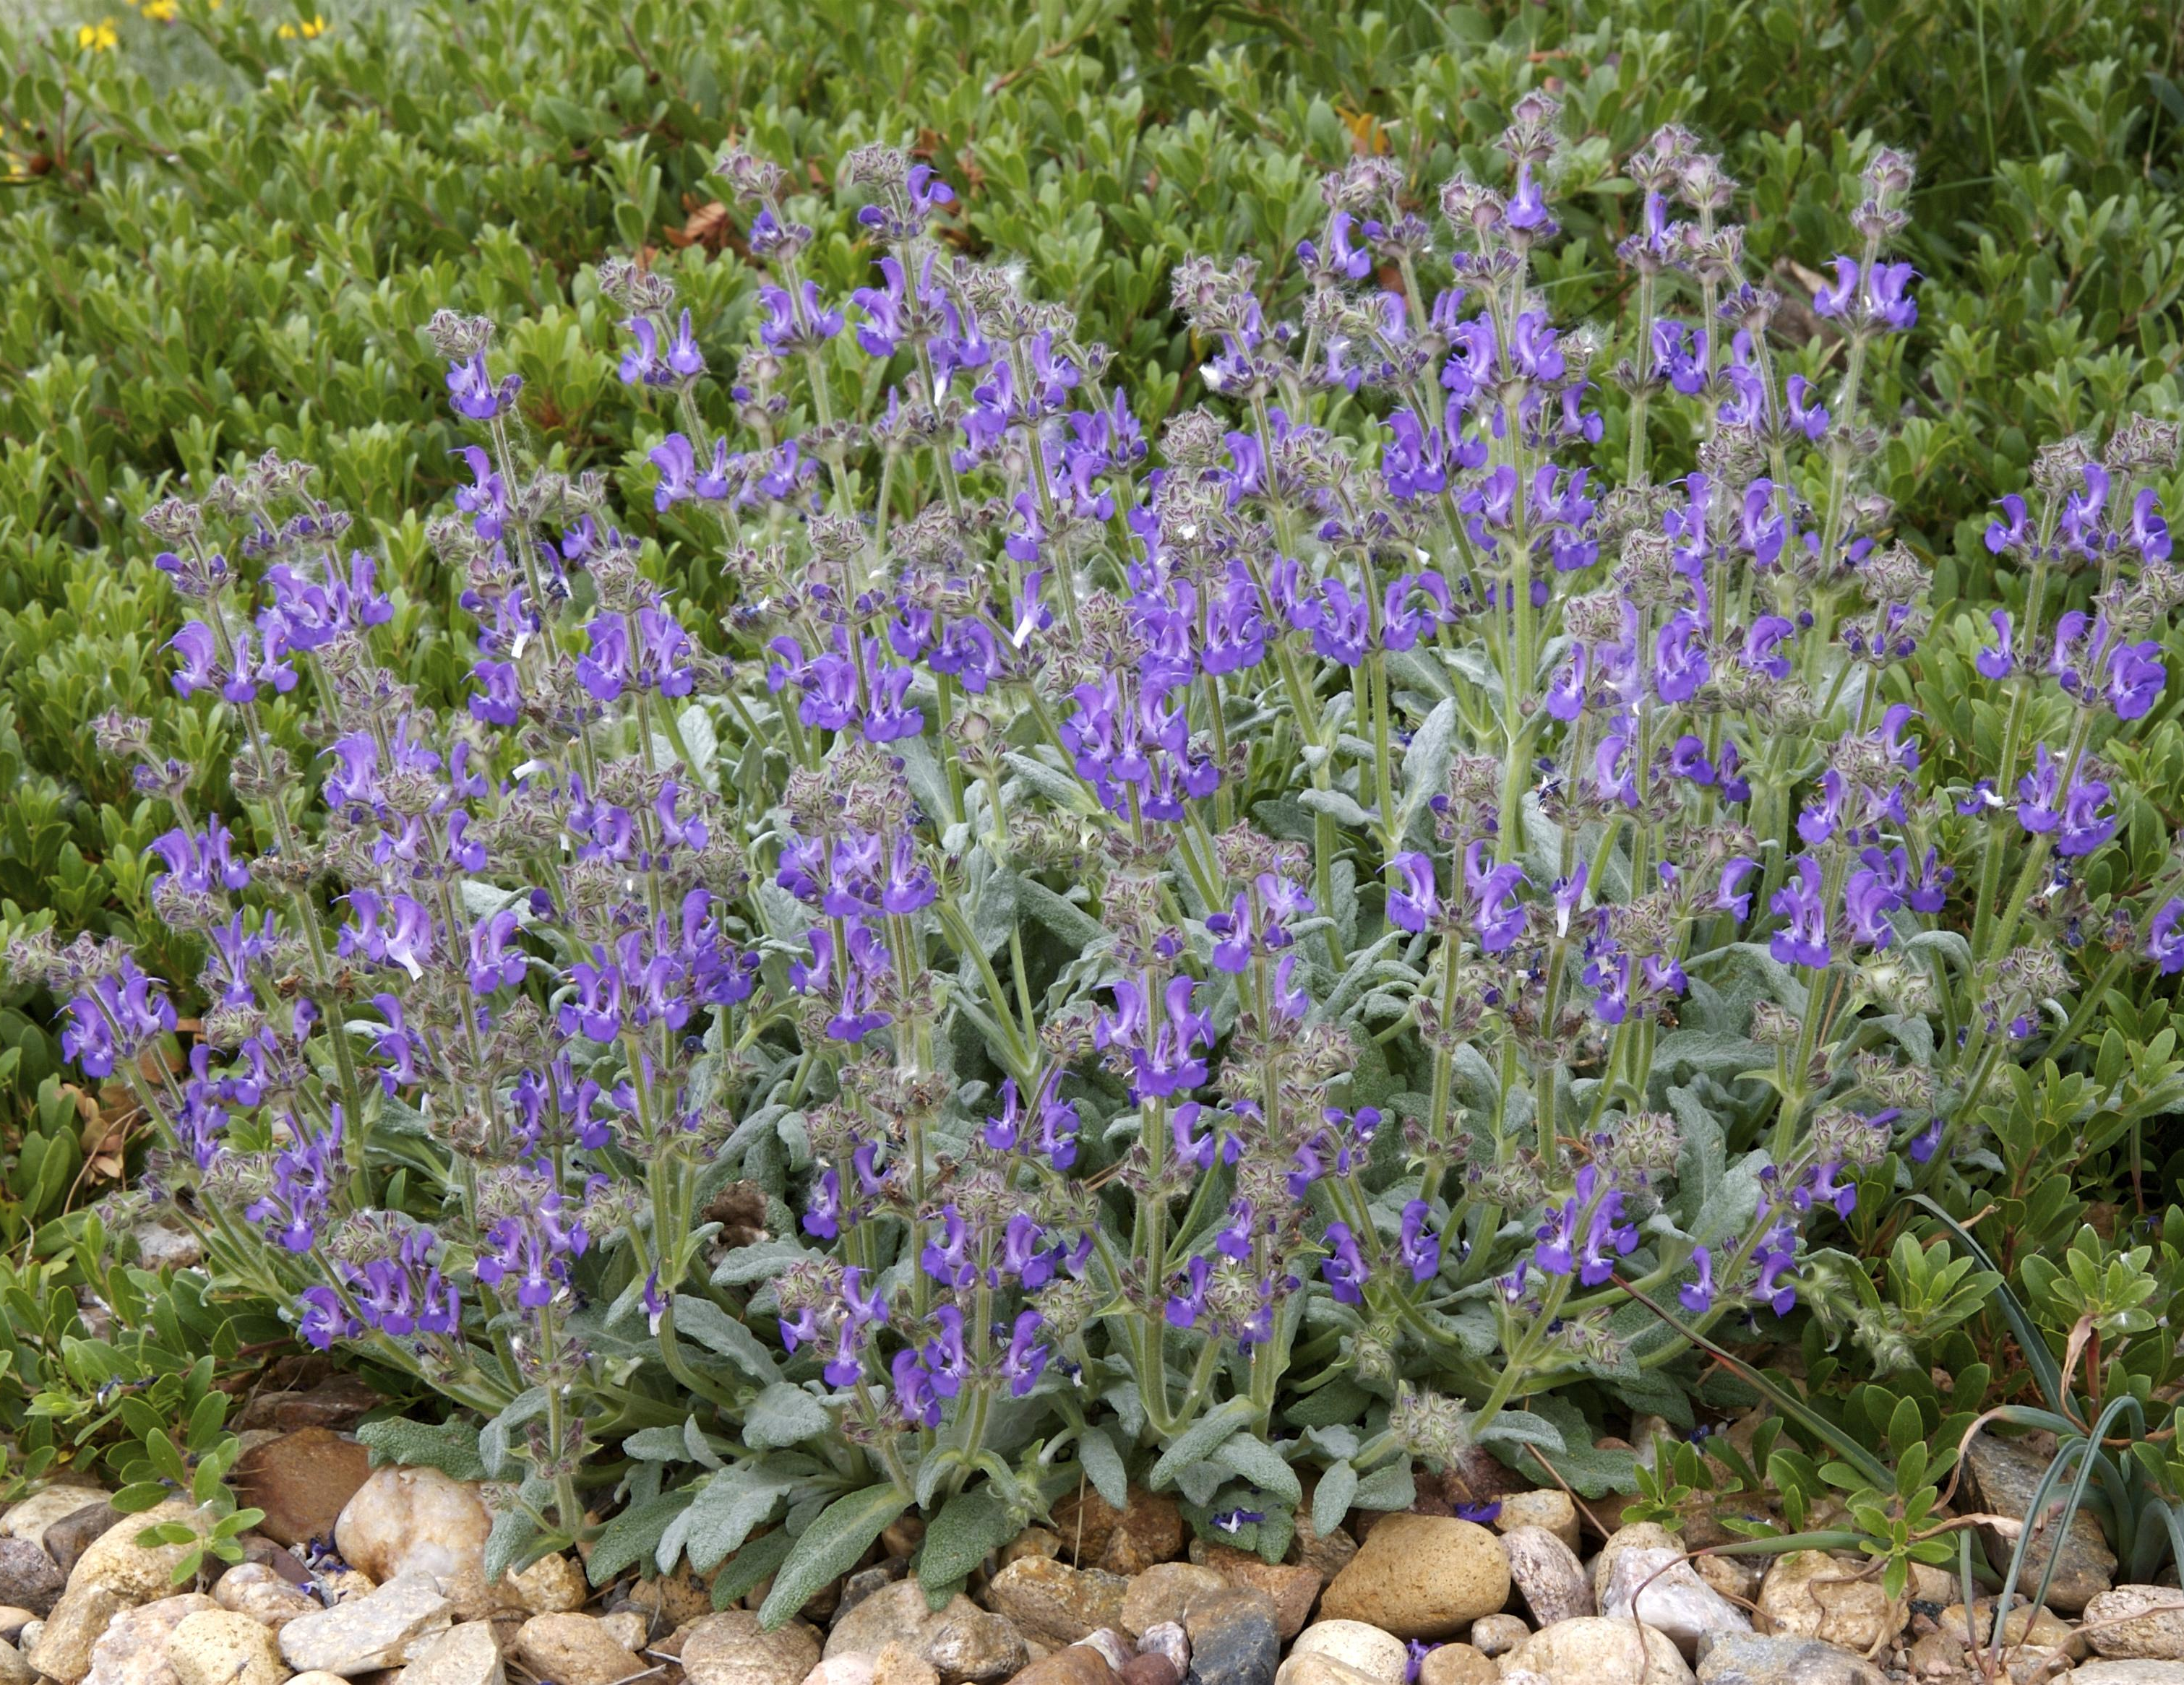




Height: 8-10”
Width: 12-18”
Blooms: Spring and early summer
Sun: Full sun to partial shade
Water: Moderate to xeric
Hardiness: USDA zones 5-10 (up to 6,000’)
Culture: Average, clay, or sandy soil with good drainage
Introduced: 2006
Perennial
Silvery white mats of beautiful foliage are studded with spires of dark blue flowers. Very hardy perennial for edging, rock gardens or as a slow spreading groundcover.

Platinum® Sage
Salvia daghestanica
www.plantselect.org

