
Platinum® Sage
Salvia daghestanica







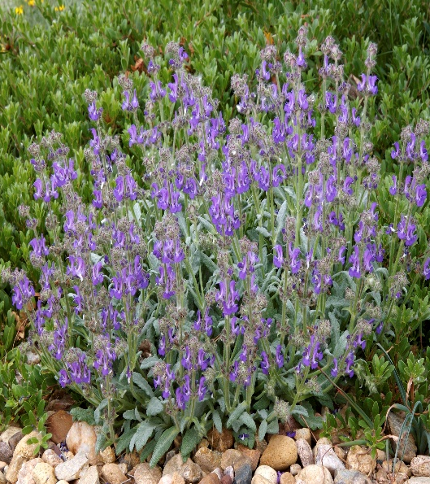


Height: 8-12 in. Width: 14-18 in.
Silvery white mats of beautiful foliage are studded with spires of dark blue flowers. Very hardy perennial for edging, rock gardens or as a slow spreading groundcover.
Culture: Loam or sandy soil
Hardiness: USDA zones 5-10



WIND. HAIL. SNOW. SUN
BRING IT ON

www.plantselect.org



