

**Platinum® Sage**

*Salvia daghestanica*

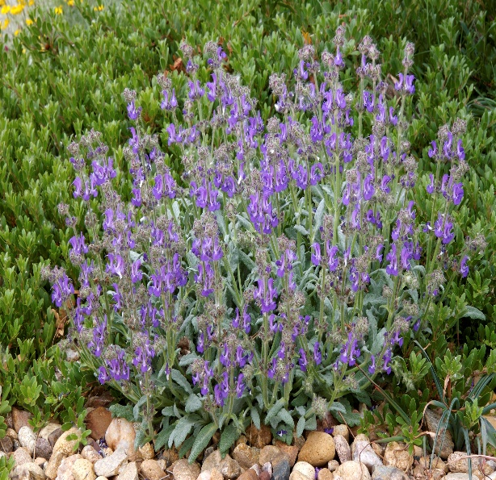

**Height: 8-10 in. Width: 12-18 in.**

Silvery white mats of beautiful foliage are studded with spires of dark blue flowers. Very hardy perennial for edging, rock gardens or as a slow spreading groundcover.

**Culture:** Loam or sandy soil

**Hardiness:** USDA zones 5-10



WIND. HAIL. SNOW. SUN

**BRING IT ON**

www.plantselect.org

