

**Silver Sage**

*Salvia argentea*

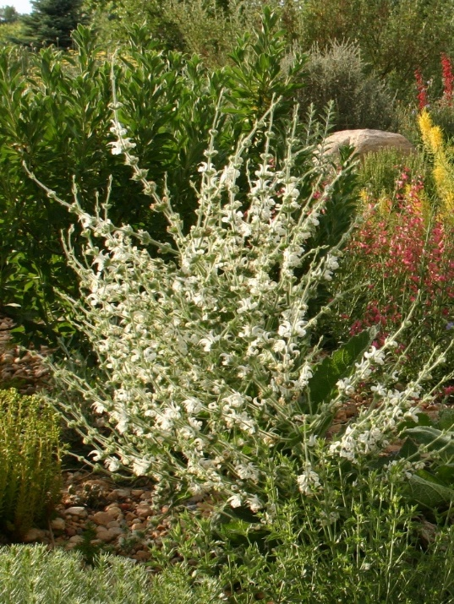

**Height: 2-3 ft. Width: 1-2 ft.**

This is a superlative foliage plant with elephant ear leaves covered with long, silky white hairs. The white, helmet-shaped flowers are produced on candelabra-like stems in early summer. This is a dramatic accent plant for the water-smart garden or perennial border.

**Culture:** Loam

**Hardiness:** USDA zones 4-10



WIND. HAIL. SNOW. SUN

**BRING IT ON**

www.plantselect.org

