

**Denver Daisy**

*Rudbeckia*

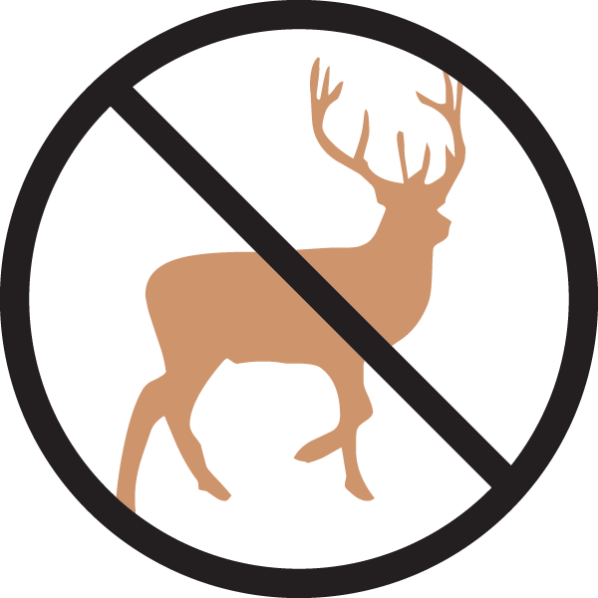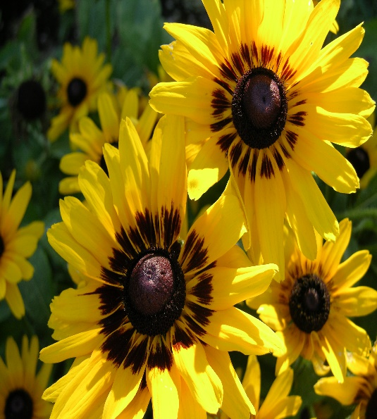

**Height: 18-24 in. Width: 18-24 in.**

Striking dark eyed, long-rayed daisy, hybridized, by Benary from the Colorado native Black-Eyed Susan (*Rudbeckia hirta*). This showy plant commemorates the 150th anniversary of the founding of Denver.

**Culture:** Gravelly, clay or loam soil

**Hardiness:** USDA zones 6-9



WIND. HAIL. SNOW. SUN

**BRING IT ON**

www.plantselect.org

